**Oracle Fusion: HCM**

* **Core HR**: Managing employee information.
* **Talent Management**: Recruiting, onboarding, performance management.
* **Workforce Management**: Time and labor, absence management.
* **Payroll**: Processing employee payments.
* **HCM Analytics**: Reporting and analytics for HR data

SAAS:

These are cloud apps provide ready to use, which are managed by Oracle.

HCM Cloud => HR, Talent Performance, Workforce Management

ERP Cloud => Finance, Procurement & Project Management

SCM Cloud => Supply Chain and Manufacturing Management

Cx Cloud (Customer Experience) => Sales, Marketing solutions

Benefits of SAAS Cloud:

No installation, No maintenance, Required from a computer

Automatic updates and Security patches

Easy to access

HCM (Human Capital Management):

A Suite of Cloud based Applications to manage HR management functions effectively.

Cloud => Workforce Management

Offerings of HCM Cloud:

Workforce Development

Workforce Deployment

Compensation Management

Recruiting Management

**Public Instance Link:**

**Instance Link :** <http://fa-launchpad.oraclepdemos.com/?params=cG9kPWV0YWosdGVuYW5jeT1zYWFzZmFkZW1vMSx0eXBlPWhyeixjb250ZW50PTI1QUQwMixjb2RlPTI1QSxpZGNzPWlkY3MtNDlmMTAwMDI4ZWE4NGQwNGI4YzU1YmZjOTcyYTljNjYuaWRlbnRpdHkub3JhY2xlY2xvdWQuY29t>

UserName : Use any of the 20 usernames SCM01.STUDENT to SCM20.STUDENT.

Password : i%2*BDh9

Oracle HCM Fusion Cloud Upgrades

Licensed User Quarterly Updates in a year

24a Jan-Mar

24b Apr-Jun

24c Jul-Sep

24d Oct-Dec

Hierarchy of HCM:

Enterprise

The Enterprise is the highest level in the hierarchy.

It represents the entire organization and encompasses

all other entities within it. (e.g: TATA)

Legal Employer/Entity

company will employee workers

Business Unit

Division

Employee Transactions

HCM Implementation Consultant Role required to access platform.

IT Security Manager Role required to access security console.

Roles:

Emp Manager

HR Specialist

HR Manager

HR Admin

Recruiter

Hiring Maager

Setup and Maintenance

Manage implementation

Project

Cloud Based SAAS RBAC(Role Based Access Control)

**Roles:**

Tools -> Security Console -> Roles -> search for role employee

Oracle Fusion HCM uses Role based access control. Employee and line manager are abstract roles

Different types of Roles:

Abstract

Seeded(Default) role. automatically assigned to all employees( Regardless of the job functions)

e.g.:

Employee, Line Manager, HR, Contingent worker(employee category or contractor)

Job

They are specific to the job function. It specifies what job, user should

perform within a module.

e.g.:

Payroll is Job function,

HR Specialist can perform job changes and employee transactions

location change, transfer.

Job Requisition is the job description

Duty

Duty roles are used to define specific actions user can take based on the privileges. There are specific to job roles, they are directly assigned to job roles. Not for users.

e.g.:

Tasks like manage and update employee records is the duty of manager.

Data

Data roles combine job roles with the security policies/profiles to restrict the access to the datasets. Cant access data without this role.

e.g.:

HR manager can only access data that belongs to the department/country, not from the other department/country.

**Role Provisioning**

**Suspension and De-provisioning**

**Reactivation of User Account**

**Person User:** User having personal record in the organization.

**Party User:**

User does not have a personal record in the organization. Party user have records where it contains project and assignment details.

Curtis.Feitty, example user for reset password

BI Admin role required to generate reports

HCM Application Administrator

HCM Integration Specialist for performing data loading related tasks.

Curtis Feitty:

Me -> Personal Information -> Personal Details here can edit the details.

Tools -> Transaction console shows transactions done by anybody, that include document submissions details, as it waits for the approval.

My Client Group -> search for hope, hightower to enter into employment information page.

Click dropdown to update/correct/delete record.

Change assignment using update.

Transferring employee from One legal to another legal entity is Global Transfer.

Transferring employee with in same legal entity is Local Transfer.

Changing location of **Honey Hopkins, Manager** user

Promoting **Adam Land** user

**User category: (Existed in the Security Console)**

Used to create constraints on Username and password. Like setting email as username according to the client requirements.

First define constraints and then add the user to the category.

We can find notifications there.

We can assign user category at the time of user addition.

**Import user and role application security data:**

To copy the users, roles and permissions from LDAP Directory.

Tools->Schedule Processes->Schedule new Process.

Retrieve user, role data from LDAP and store in Application security tables.

We can schedule the process to run on daily basis.

e.g: create, suspend and reactivate, employee is rehiring

Role: BPM Workflow Human Capital Management Administrator.

It is used to setup approval roles and manage approval submissions

**BI Publisher(need SQL Knowledge) and OTBI(no need of SQL)**

**BI Publisher (need SQL Knowledge) and  
OTBI – Oracle Fusion Transactional Business Intelligence(no need of SQL):**

Fetch all employee details, You can use Reports and Analytics, export to excel and share it with clients.

**BI Consumer** Run and View BI Reports

**BI Admin** provides administrative capabilities like managing security permissions, creating editing

**BI Author** creates and edit BI Reports

**BI Admin** inherits **BI Author** inherits **BI Consumer**

**Manage role provisioning rules**  are used to specify conditions under which roles are applied.

**Security Profiles**  are used to specify conditions under which data is restricted, example view all employees, view all countries.

**Data Integration Tools:**

**HCM Integration Specialist Role** for HDL and HSDL, then data exchange app will be visible.

HDL (HCM Data Loader) – upload bulk data of employees, .dat extension file used

HSDL (HCM Spreadsheet Data Loader)- for ad hoc updates

OTBI

BI Publisher

Add security profile to job role then data role is created

**Core HR Implementation:**

Core HR is the main Module to implement, to manage every stage of employee life cycle.

Setting up HCM: Plan Configure Setup Deploy Maintain

Geographic Structure: Define structure, in the manage geography structure task.

Manage Geographies -> Import Management, Oracle licensed Geography Reference data.

Manage Geography Validation:

>Address Style Format

>Address Style Format Mapping

State

County

City

Postal Code

**Enterprise Structure Configurator**:

ESC Consists of components that we configure according to client.

Divisions, Legal Entities, Business Units, RDS, BU Set Assignment, Assign Reference Daa Sets to Locations.

Setup and Maintenance -> Tasks Panel Icon -> Manage Implementation Project

In above location, we can find the tasks in one place, instead repeatedly visiting setup and maintenance.

Workforce Deployment -> Enterprise Profile -> Establish Enterprise Configuration -> Load Geography for Country_Name -> Manage Geographies -> Load Geographies -> Define Enterprise Structures for HCM

Enterprise Profile -> Manage Geographies ->

Establish Enterprise Structures -> Goto Task

Tools->Reports and Analytics

**Position Synchronization Corporation**:

Incumbent-Head Count, SDM(Me) have manager as Ramu, then if another one joined the SDM (My Friend) Role also get same Manager, then the department and location details are automatically populated when we select Position Synchronization.

Manage Position Trees

**Set Enabled Objects, Set ID** is also called References Data Sets

Position codes are automatically generated by Legal Entities from Manage Legal Entity HCM Information.

A LE hires an Employees/workers. It is required for payroll and statutory reporting compliance.

Position is specific instance of job within department.

Payroll Manager is the Position, and Payroll is the Department.

**Person Number** to identify the employee details.

**Assignment number** is to identify the assignments for a person, for employees it is “e-” and for contractors it is “c-”, then if it is multiple assignment there exists “2” in it.

At least one Legislative Data Group (LDG)

Legal Entity, Legal Employer, Payroll Statutory Unit.

**Legal Reporting unit** is also called as Tax Reporting Unit.

Manage Person Type Task to add new person, like adding a trainer.

Setup and Maintenance - Task Panel – Manage Implementation Project – create new – Workforce deployment – enable all – then save.

Go to that Implementation Project - Define Common Applications in HCM - Establish Enterprise Structures, then Create one Enterprise.

Workforce Deployment – Define Common Applications Configuration for HCM* - Define Enterprise Structure for HCM* - Define Legal Jurisdiction and Authorities for HCM* - Manage Legal Jurisdiction – click create (+) – give details – click save and close.

The details are given by client.

Manage Legal Authority – create legal authority – create address - click save and close.

Manage Legal Addresses – to create the legal addresses to assign to legal authority.

Legal address defines the physical address of the organization.

Create one location in Manage Legal Address.

Manage Legislative Data Group – create a legislative data group.

Manage Geographies – check whether all are enabled.

Manage Legal Entities – click select – Manage Legal Entity – select and add – search for the legal entity – create legal entity by selecting the legal address (we will give registration information) – enable Payroll Statutory Unit and Legal Employer.

**Manage legal Entity HCM Information** – Goto Task – select Legal Employer – give work start time, end time and Standard Hours Frequency - In Legal Employer – 2 Tier Single Assignment – tab LDG – add the legislative Data Group - Done.

Fiscal Year Start means start of Financial Year.

Manage Legal Entity Tax Profiles – search legal entity and edit that – give associated fiscal classifications.

Legal Entity Calculation Card is used to process the payroll

Legal Entity Calculation Card – give name and effective as of date – calculation card for pensions.

Define Legal Reporting Unit for HCM* - click select – choose select and add – select the Legal Reporting Unit – save and close.

Legal Reporting Unit for HCM Information – check tax reporting unit and Reporting Establishment – next and submit.

Select Tax Reporting Unit and then associate legal employer.

Manage Legal Reporting Unit HCM Information

Manage Business Unit – Create Business Unit –

Workforce Deployment – Define Common Application for HCM* - Define Enterprise for HCM* - here we can find Legal Entities, Business Units and Jurisdictions.

**Legal Reporting Unit**: Generate reports for government taxation, we need legal reporting units. To comply with that country’s specific taxation. Tax, payroll and compliance.

**Legal Reporting Jurisdiction**: Geographical area which follows tax and labor laws, as we need obey the country’s taxation policy. Geographical tax and legal boundaries.

Business operated in multiple countries, then we need to use the Legal Reporting Unit=-0\and Jurisdiction.

|  |  |  |
| --- | --- | --- |
| Features | LRU | LRJ |
| Purpose | Tax, Payroll, Compliance | Defines Geographic Tax, Legal Boundaries |
| Scope | Sub-division of LE for compliance | Area where company follows legal rules and regulation. |
| Usage | Payroll Processing, Tax Filing, social security reporting | Taxation, Labor Laws, Corporate Compliance |
| Example | LRU Bangalore, LRU Mumbai India | GST – India, Income Tax, US |
| Explanation | An LRU is responsible for managing the tax deducted from employees and their salary management. It ensures that all employee-related tax and payroll activities are compliant with local regulations | An LRJ manages the taxation and compliance regarding the company's existence within a country. It ensures that the company adheres to the legal and tax requirements of the specific jurisdiction |

Location where business is conducted, including its physical appearance.

If client want any additional fields, Manage Common Lookups helps to create more dropdown values/options.

Legal Jurisdiction, for **Identifying** Field select Yes, as it represents the first legal jurisdiction for the legal entity with in a country.

Start date is considered with creation when it was not given.

Legal reporting unit is created when the Legal Entity is created, with the same name.

LDG is partition of payroll and related tasks, at least one LDG for Country where organization resides. They can be assigned in Manage HCM Information.

Each Legal Entity can have Multiple LDG.

Each payroll can be given to LDG.

PSU is parent of RU, as they are parent child relationship.

A legal employer is a legal entity that employs workers.

Tax Reporting unit( also called Legal Reporting Unit ) is used to group workers for the purpose of tax and social insurance reporting. Manage Legal reporting task is used to configure.

One Legal Entity can be Legal Employer, It may not contain the payroll statutory unit, if If the payroll statutory unit is not in LE, then we can refer parent payroll statutory unit to process the payroll related tasks.

Organization is nothing but department.

**Reference Data** is data (jobs, Organization, locations and grades) in application table, which is shared among different parts of the organization.

Calendar Events used to upload holidays including start date and end date.

**Single Incumbent**

* **Definition**: A position type where only one person can occupy the role at any given time.
* **Example**: A company might have a single CEO position. Only one person can be assigned to this position, ensuring clear leadership and responsibility.

**Shared and Pooled Positions**

* **Shared Positions**: Multiple employees share the same position, often with different Full-Time Equivalents (FTEs).
  + **Example**: A part-time teaching position shared by two teachers, each working 50% of the time.
* **Pooled Positions**: A group of employees can be assigned to the same position, typically used for roles requiring flexible staffing.
  + **Example**: A customer service team where multiple agents are pooled together to handle incoming calls.

**Grade with Steps**

* **Definition**: Grades can have steps that represent incremental levels within the grade, often tied to salary increases.
* **Example**: Grade A might have steps A1, A2, and A3, where each step corresponds to a higher salary.

**Grade Step Progression**

* **Definition**: A process that automatically moves employees from one grade step to the next based on predefined criteria.
* **Example**: An employee starts at Grade A1 and progresses to A2 after one year of service, then to A3 after another year, with each step involving a salary increase.

**Grade with Minimum and Maximum Values**

* **Definition**: Each grade has defined minimum and maximum salary values to ensure compensation is within a specific range.
* **Example**: Grade B might have a salary range from $40,000 to $60,000. Employees within this grade cannot be paid less than $40,000 or more than $60,000.

**Grade Rate for Salary Hike**

* **Definition**: Grade rates are used to determine salary adjustments and hikes based on the employee's grade.
* **Example**: If an employee is in Grade C with a salary range of $50,000 to $70,000, a salary hike might be calculated based on their current position within this range. For instance, moving from $55,000 to $60,000

My Client Groups -> Workforce Structures -> New Positions -> [ Fill all the details ] -> submit

My Client Groups -> Workforce Structures -> Manage Position Tree -> [Enter name, Code, then next, and next, submit] ,

Select the tree, create tree version (by clicking on the tree), -> [Give name, code] -> then map the nodes to it -> In search Node, search for US1 Business Unit then add to the tree node.

Use Specify Node train stop.

Click actions then set status to active (draft to active).

My Client Groups -> Workforce Structures -> Job Families - > [Give effective start date, active reason, status active, Name and code] –> click submit.

My Client Groups -> Workforce Structures -> Grades -> [provide all details, including the reference data set] -> next -> Give code and names -> next -> Now add grade steps.

Positions - to check the position tree is created or not.

Manage Position Tree is used to create the position tree.

**Oracle Cloud Financial** is an Open Standard based Enterprise Application that function in the cloud through web browser.

**Features**

Multidimensional reporting platform

**Oracle Enterprise Resource Planning** is a type of software used to manage day-to-day business activities, such as accounting, procurement, project management, risk management, compliance and supply chain management.

Oracle ERP runs on Gen-2 cloud Infrastructure.

General Ledger

Account Payable

Account Receivable

Cash management

Fixed assets

Expenses

Advanced Collections

**Oracle ADF Desktop Integrator** is a plugin used to integrate data from multiple systems. It collects data from sub-ledgers.

**General Ledger Overview**

Information access

Financial Controls

Data Collection

Financial Reporting and Ana

**Invoice** list of items that were shipped to the supplier.

**Payables** is an invoice, that include financial information regarding the goods supplied.

After Entering suppliers. **Payables** (**Payable Open Interface)** validates the invoices, then creates the subledger accounting.

**Receivables** enables you to create all transactions to correctly bill customers, record payments, and perform adjustments to customers’ accounts.

**Cash Management** import the bank statements (manually or automatically) for the reconsideration process, to check whether the payment is valid or not. At GLs reconsideration will be done. It includes financial decision making.

Receivables

Payables

Cash Management

Payrolls

**Create Accounting** task is used by above.

**Subledger Accounting** generates entries for payables, receivables and cash management transactions.

A **legal entity** is a registered company or other entity recognized in law.

owns assets of the enterprise.

Record sales and pay tax on sales.

Make purchases and incur expenses.

Perform intercompany trading.

Each legal entity can be associated with ledger, use a balancing segment value, when we are assigning multiple LE to ledger.

One LE – One Ledger

Multiple LE – One Ledger

Balancing Segment Value

**Financial Reporting includes 4C’s:**

Chart of Account

Calendar

Currency

Accounting Method or Convention or Compliance Method

**Components of Chart of Accounts**

**Structure** is used to define key attributes of your chart of account. A structure can have up to 30 segments with each segment of 240 characters maximum length.

**Segment Labels**

**Primary Ledger** is associated with the sub ledgers, whereas **Secondary Ledger**  is associated with the Primary Ledger.

In SL there are **four levels of Conversion**,

Balancing Level

Journal Level

Subledger Level

Associated Level

* LRU: You create an LRU for each region to handle local legal reporting, such as new hire reporting and compliance with labor laws.
* TRU: You designate these LRUs as TRUs to handle payroll tax and social insurance reporting, ensuring that each region's tax obligations are met accurately.

**Definition:** A Payroll Statutory Unit (PSU) is a legal entity responsible for paying workers, including the payment of payroll tax and social insurance. A PSU can pay and report on payroll tax and social insurance on behalf of one or more legal entities, depending on the structure of your enterprise.

**Definition**: Legislative Data Groups (LDGs) are a means of partitioning payroll and related data. Each LDG is associated with one or more PSUs and is used to organize payroll-related information, such as elements, within a specific legislation.

**Lookups:**

It is mainly used for translation. Lookup types are used to group related lookup codes. Meaning is used to describe the lookup to the user.

Gender (Lookup type) – M, F (Lookup codes) Males, Female

Lookup codes are same irrespective of the language, lookup types may differ.

Lookup codes are not translated, where remaining meaning and lookup types are translated. For codes, they translated meaning is used instead of directly

**Task:** Manage Common Lookups.

**Configuration Levels:**

**System/Standard [**given by oracle, add and delete are not possible, only meaning and description be changed**]**

**User [**add and delete anything**]**

**Extension [**some of the lookups codes are given by oracle (not able to delete and update), some of them are user created (can delete or update)**]**

**Four tables are used to store the data:**

FND_LOOKUP_TYPES – 1 row will be created here for Lookup Types.

FND_LOOKUP_TYPES_TL – 200 rows created here for Translation Languages.

FND_LOOKUP_VALUES_B – stores lookup values

FND_LOOKUP_VALUES_TL – M or F (each value’s translated meaning in 200 languages) [M in 200 Languages, F in 200 Languages, Total 400 records]

**FND_LOOKUP_TYPES**:

* + **Purpose**: Stores the lookup types.
  + **Example**: If you have a lookup type "GENDER," one row will be created in this table for "GENDER."

**FND_LOOKUP_TYPES_TL**:

* + **Purpose**: Stores translations for lookup types.
  + **Example**: If "GENDER" needs to be translated into 200 different languages, 200 rows will be created in this table, one for each language.

**FND_LOOKUP_VALUES_B**

* **Purpose**: Stores the base values for lookup types.
* **Data**: Contains the actual lookup codes and their associated metadata.
* **Example**: For the lookup type "GENDER," it might store codes like "M" for Male and "F" for Female.

**FND_LOOKUP_VALUES_TL**

* **Purpose**: Stores the translated meanings of the lookup values.
* **Data**: Contains translations of the lookup codes' meanings and descriptions in various languages.
* **Example**: For the code "M" (Male), it might store translations like "Masculino" in Spanish and "男性" in Japanese.

To refer structure of the above tables: <https://docs.oracle.com/en/cloud/saas/applications-common/25a/oedma/fndlookuptypes-16086.html#Details>

**Value Set:**

It is used for the validation of the data.

Data Type Validation

FormatOnly Value Set

Drop Down List

Independent Value Set: All the values are hard coded.

Dependent Value Set:

Table Value Set

Subset Value Set

**Task:** Manage Application Core Value Set

Better to use XX_, as the user created sets and lookups cant get affected by oracle patches.

We can use enable security enabled to restrict values.

_VL: _VL is a view that joins _B and _TL.

Better to use _VL, as it contains codes and translation together.

Enable Flag is similar to where clause in the Table Value set. If the enabled flag column flag has a value ‘Y’(Yes), then it is included, otherwise not.

Start Date and End Date acts as “between start Date and end Date”

In where clause, we need to write the entire expression.

**Flexfields** are used to add customizable fields to the application, so that additional data can be collected with this flexfields.

All the Flexfields are combination of fields.

**Key Flexfields (KFF)** used to identify a business object. In KFF, combinations are unique. Combinations of fields cannot be created.

It has own table and reference is used in other table(foreign key).

Maximum number of columns are fixed.

30 – columns

Context is Mandatory Google Forms Fields + KFF Context ({code , number})

e.g. General Ledger, Inventory Locator. Currency, Calendar, Compliance Method, Chart of Account

Ledger (C, C, CM, CA) - extra

**Descriptive Flexfields (DFF)** used to obtain more descriptive information for any business object. Combination can be repeated. It is stored in the same table as the business object.

Maximum number of columns are fixed.

30 – Character, 30 – Number, 10 – Date, 5 – Datetime columns

Available for all objects.

Context is optional.

If context is not defined, then the global context is used.

e.g. Extra information for customer, Item, AP Invoice.

**Extensible Flexfields (EFF)** used to obtain more descriptive information for any business object. Combination can be repeated. It is stored in another table, linked by primary key of the business object.

Unlimited number of columns.

Available for only few objects.

Context is Mandatory.

e.g. Person Extra Info, Position Extra Info.s

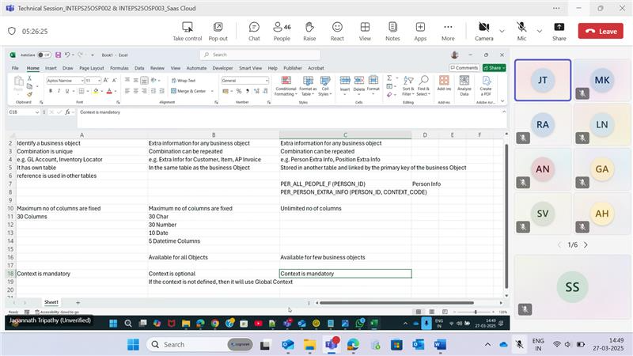

Every Flexfield have context, context will have segments (attributes or columns).

Like above we have different flexfields like for receivables.

**Profile Options:**

They are used to define and assign/set variable with corresponding values. It is used for the configuration.

Define Profile Option.

Set the value for the profile option.

**Task:** Application Profile Option

Create profile option

Give profile option code

SQL Validation it may contain one column or two columns

If it is one column - display value and internal value are same.

If it is two columns – first column for display value and second value for internal value.

It should be 1-to-1 Relationship.

AFLOG_ENABLED

**Configuration level for Profile Options:**

Site – can be enabled , can’t update.

Product – can’t enabled, can’t update.

User – can be enabled and can be updatable.

You can set this values to the user with the help of username.

User level value, if value not available -> Product level value, if value not available -> Site level value will be used, because it cannot be deleted.

Goto Person Information, select a person and then click Extra Information.

**Practice Task for KFF:**

**Task:** Manage Inventory Locator Key Flexfield

Perform the task in Inventory Management.

GL Accounts is an example of Key FlexField, which is a combination of multiple segments/attributes, these segments/attributes combination forms a Key Flexfield. The Combination is unique, so values cannot be repeated.

101.326.45678.903.400

Company.LineOfBusiness.NaturalAccount.CostCenter.Etc

Structure is nothing but Context(group) which contains Segments(attributes).

**Task:** Manage Key FlexFields Structures.

Give Structure code and Name, select delimeter in above example it is ‘.’

Then create Segments.

Create Structure Instances in **Manage Structure Instances**, we use the structure instances to enter the data, same structure can be used for multiple instances.

Then in the instances page, make all the fields as required by clicking the edit symbol button.

Then deploy the flexfield.

**Testing the Flexfield:**

Select Manage Subinventory and Locators.

Then Create Subinventory, by giving name,

In Location Structure, select the instance that is created previously.

Click save and close.

Click Manage Locators.

Then the key flexfields are displayed.

Example task to create key flexfields, Manage Account Combinations.

Segments cannot be edited when combination is created.

**Practice Task for DFF:** Manage Receivables Descriptive Flexfields

Flexfields are already created. We need to add the fields.

Select the flexfield, click (+), provide name, code and api name, under context sensitive segments, click +, provide name and code, use existing validation set.

Manage Application core value sets

Goto Homepage, Receivables, create transactions, then select your context, then corresponding fields were added to the interface.

**Practice Task for EFF:**

Manage Person Extensible Flexfield.

Manage Context.

Usage: usage code for person.

Create Segment.

Issue date should be lesser than return date, so choose wisely from the record type.

Unit Of Measure (UOM), we can specify units with UOM.

Associate the context in the Associated Contexts.

Create a page and add the context to that page.

**Quiz Answers (Only few answer were correct):**

1. **What does ERP stand for?**
   * Enterprise Response Process
   * Enterprise Resource Process
   * Enterprise Resource Provisioning
   * **Enterprise Resource Planning**
2. **Which among these is not an ERP?**
   * Oracle eBusiness Suite
   * Oracle Fusion Applications
   * **Oracle Fusion Middleware**
   * NetSuite
3. **Which among these is/are Oracle cloud offering?**
   * **NetSuite**
   * **VBCS**
   * **Oracle ATP**
   * Oracle XE
4. **Which among these is/are Oracle PaaS offering?**
   * **VBCS**
   * **Oracle SOA Suite**
   * NetSuite
   * **OIC**
5. **Which among these is/are Oracle SaaS offering?**
   * **Oracle Fusion Applications**
   * **NetSuite**
   * Oracle ATP
   * Oracle Symphony
6. **Which among these is/are Cloud Offering Type?**
   * **Software as a Service**
   * **Platform as a Service**
   * Identity as a Service
   * **Infrastructure as a Service**
7. **Which process flow in Oracle mandatorily involves Customers?**
   * Procure 2 Pay
   * **Order 2 Cash**
   * Record 2 Report
   * Hire 2 Retire
8. **Which process flow in Oracle mandatorily involves Employees?**
   * **Procure 2 Pay**
   * Order 2 Cash
   * Record 2 Report
   * **Hire 2 Retire**
9. **Where do we define "Segregation of Duties"?**
   * Users
   * **Roles**
   * **Privileges**
   * None of the above
10. **What are the validation types of Value Sets in Oracle Fusion?**
    * **Independent**
    * **Table**
    * **Subset**
    * Special
11. **What are the data types of Value Sets in Oracle Fusion?**
    * **Character**
    * **Number**
    * Boolean
    * **Date**
    * **Date Time**
12. **In order p create which type of valueset, you must first create an Independent Valueset?**
    * Special
    * **Subset**
    * **Dependent**
    * Table
13. **Which is not a flexfield type?**
    * Key Flexfield
    * Descriptive Flexfield
    * Extensible Flexfield
    * **Customizable Flexfield**
14. **Which is the correct sequence?**
    * **Flexfield - Context - Segment - Valueset**
    * Flexfield - Segment - Context - Valueset
    * Flexfield - Valueset - Segment - Context
    * Flexfield - Valueset - Context - Segment
15. **Is it mandatory to assign a valueset to every segment?**
    * **Yes**
    * No
16. **Which flexfield supports multirow behaviour?**
    * Key Flexfield
    * Descriptive Flexfield
    * **Extensible Flexfield**
    * Customizable Flexfield
17. **Which cannot be assigned directly to a user?**
    * Job role
    * Duty Role
    * **Abstract Role**
    * **Privileges**
18. **Which menu option is used to assign roles to a user?**
    * **Security Console**
    * User Management
    * Role Management
    * Segregation of Duties
19. **Which menu option is used to submit a background job?**
    * Scheduled Jobs
    * Scheduled Tasks
    * **Scheduled Processes**
    * Scheduled Reports
20. **While doing FBDI, which is the correct sequence of storage?**
    * Interface Table - Base Table - UCM
    * Base Table - Interface Table - UCM
    * Interface Table - UCM - Base Table
    * **UCM - Interface Table - Base Table**
21. **Which type of reports can be submitted as part of Enterprise Scheduler Service jobs?**
    * Smartview
    * **BI Publisher**
    * OTBI
    * None of the above
22. **Where can we see the mandatory tasks for a setup?**
    * Module Setup Wizard
    * **Functional Setup Manager**
    * Setup Tasks Search
    * Technical Setup Manager
23. **Which can be assigned as part of data security?**
    * Job Role
    * Duty Role
    * **Ledger**
    * **Inventory Org**
24. **Which is the correct Legal Structure?**
    * **Legal Entity - Business Unit - Inventory Org**
    * Inventory Org - Legal Entity - Business Unit
    * Business Unit - Inventory Org - Legal Entity
    * None of the above
25. **Which among these can be mapped to a User (login id) in Oracle Fusion?**
    * Employee
    * Supplier
    * Customer
    * **All of the above**

**Procure 2 Pay:**

Procurement starts when there is a need. You want to Purchase.

Every employee creates a requisition to record the need to purchase.

Automatic Requisition is also possible.

**Three Types of items:**  
 1) Raw Material – Input material used to produce Finished Product.

2) Assets – Like Building, which is not sold.

3) Expense Items – Used immediately, consume, and terminate.

**Lifecycle:**

Create a Requisition -> Requisition Approval {Approval against the budget (Finance Approval) and business need(Business Approval)} -> Identify all possible Suppliers -> Send a Request for Quotation(RFQ) to the Suppliers {Contains Item detail/description, Quantity, Need by which date, description} -> Suppliers send RFQ Response (Delivery Date, Terms & Conditions, Price) -> Company sends Negotiation to the Suppliers -> Negotiation will be awarded -> Then Purchase requested/order will be created against the supplier -> Suppliers sends Purchase Order Acknowledgement to the Company(It is Optional) -> before sending material suppliers will send ASN(Advance Shipment Notice) to the company -> After material is received, Material will be inspected(Company Accept or Reject)

**When accepted**, the material is added to the company inventory called “put away(process when material added to the inventory)” -> Company send Material Received -> Then suppliers send Standard Invoice(This Standard invoice have payment due date under Payment Term) -> Payment will be made on or before due date.

**When rejected**, Return Material Authorization – Return to the supplier process involves requesting for RMA, then material will be returned to the supplier.

**Invoice, Payment (Mandatory), creation of purchase order, Inventory Management(Optional) -> Ledger will be affected mandatorily, as money is involved.**

**Modules Involved in z:**

Procurement Module

Sourcing

Inventory Management

Payables

General Ledger and Cash Management

When you return a material, then supplier sends a **negative invoice(Credit memo)**, if supplier doesn’t send, then the company will create a **negative invoice (Debit Memo)** on behalf of the company side, While waiting for the next standard invoice.

**Prepayment** invoice is created by the company against the supplier, when supplier request an advance for the material, that will be supplied.

**Approved Supplier** List, for a material, if I know a supplier(may be easier one to negotiate), keep it ready to use to purchase suppliers by reducing time in negotiation.

**Purchase Agreement/Blanket Purchase Order** ensure that company will buy the certain quantity(optional) of material from a supplier with price (Mandatory) for 1-year or other terms. Used to avoid negotiation. As we negotiate in the initial purchase.

**Another form of Procure 2 Pay Expense Report:**

Some employees will be given purchasing power with some amount locked. To purchase some materials

e.g. employee went to onsite, then employee spend money, then submit expense report to the company, then employee will be paid.

**Order 2 Cash:**

It is opposite 2 pay process, we sell something and receive money.

When you receive sales order from your customer.

**Lifecycle:**

Receive the sales order -> Enter the order in your system -> Order Booking{Confirming the order, Confirm ATP Date (Available to Promise it will consider manufacturing information: Time taken to manufacture, Need of raw material for the required quantity, shipping these all are based on customer date) } -> Shipping the Items(Pick the Item from the Inventory, Pack it and Place it in the shipping location) -> Then customer receive the ship confirmed -> then, company creates Account Receivable Invoice send it to the customer -> customer performs payment -> Company receives payment.

**Modules in Order 2 Cash:**

Order Management

Shipping

Inventory Management

Receivables

General Ledger

Cash Management

**Back 2 Back:**

When item is not available with a supplier, and another supplier have that item, then supplier (who don’t have that item) creates a Back 2 Back Order(purchase order against the actual supplier order).

It is a purchase order, which is created when company receive sales order from a customer.

**Dropship**, in dropship Item will be delivered from supplier to customer, without involving it to the inventory.

**In Positive Invoice**

AP – sending money.

AR – receive money.

**In Negative Invoice**

AP – receive money.

AR – sending money.

**Note:**

AP – You should have the invoice first, then make a purchase.

AR – You can receive money without invoice.

Oracle ATP is database on cloud.

Netsuite and VBCS are oracle offerings.

**Record 2 Report:**

Only involves general ledger, where you record transactions, and create a report.

**TCA**

* BI Publisher Desktop
* Notepad++
* Postman
* SOAP

**Trading Community Architecture:**

purpose, whether receive money.

HZ_PARTIES will store party information.

HZ_PARTY_SITES will store party site information.

HZ_PARTY_SITES have location ID.

HZ_PARTY_SITES is linked to HZ_LOCATIONS, which contains address.

HZ_PARTY_SITE_USES store the information related purpose of the party.

Every site will have contacts, Contact is also a party.

HZ_CONTACT_POINTS will store how to communicate with site/person.

HZ_PARTY_RELATIONSHIPS will store the relationships, from party to party, vice versa, relationship always stored in pair.

HZ_CUST_ACCT will store customer details. Party id is stored in HZ_CUST_ACCT, but customer account id not stored in HZ_PARTIES.

HZ_CUST_ACCT_SITES.

HZ_CUST_ACCT_SITES_USES.

POZ_SUPPLIERS

POZ_SUPPLIERS_SITES will stores flags, purchasing side flag.

AP_BANKS

AP_BANK_BRANCHES

AP_BANK_ACCT, will not related to AP_BANK

PER_ALL_PEOPLE_F : people can have addresses

PER_ADDRESSES_F

PER_ADDRESS_USAGES_F

PER_PERIOD_OF_SERVICE contains hire date.

**Date Tracking:**Date Tracking allows you to retain the history of the updates.

By adding effective start date and effective end date as part of the primary key(Composite ID { PersonId, Effective Start Date and Effective end date}).

End of time for oracle 4712*

**Correct** will uspdate Based on Session Effective Date, correct will update the Record, without effecting the Eds

**Current Effective Record** record which is currently being edited with corresponding ID.

**Update** If there is future change exists, then update will done in two modes,

Id ESD EED

1 2/Apr/2025 30/Jun/2025

1 1/Jul/2025 31/12/4712

**Update change insert**

The end date of the current pointing record is changed and new record is inserted

**Update Override**

The end date of the current pointing record is updated, and the all future records get deleted, then the end date of the future record is used as then EED of the newly inserting record.

**Id ESD EED**

1 2/Apr/2025 30/Jun/2025

1 1/Jul/2025 31/12/4712

**Delete** It can be done in two modes.

**Delete End Date** It removes the future records and EED of current effective record, then the EED of the future records will be used for the removed record’s EED in first step.

**Id ESD EED**

1 2/Apr/2025 30/Jun/2025

1 1/Jul/2025 14/Jul/2025

**Delete Purge,** delete all the records with same ID.

**Tables ending with _F** indicates that Date Tracking Table.

**Rule:** Add <> between ESD and EED to the Date Tracking Tables.

**Tables ending with _X** views are created on _F Tables, gives the records that are only effective today.

**Assignments**

PER_ALL_ASSIGNMENTS_M, _M indicates you have multiple records with same effective date.

PER_ALL_PEOPLE_F – Person.

PER_ALL_ASSIGNMENTS_M – Assignments.

PER_PERSON_NAMES_F – Names, it have column Name Type {GLOBAL, LANGUAGE_CODE these two values stored in the table}.

**Address**

PER_ADDRESSES – will store the actual address, will have postal code, address line1, 2…

PER_ADDRESS_USAGES – person id, address id, address usage type{permanent or temporary address}.

**Managers**

PER_ASG_SUPERVISORS_F – Default manager is Line Manager. It have the column, MANAGER_TYPE {LINE_MANAGER}

Person id, person manager id, assignment id, person assignment id, manager type.

**Note:**

Information that is not going to be changed will stored in non-date track table

e.g., Date of Birth

HR_ALL_ORGANIZATION_UNITS

HR_ALL_ORGANIZATION_UNITS_TL will have the Organization Names. Use filter on Language such as GLOBAL or Language Code.

If you want to take the current session language code dynamically: USERENV(‘LANG’). Otherwise, you will get duplicate records.

PER_JOBS_F – will have job attributes except name

PER_JOBS_F_TL – will have job name and id

PER_ALL_ASSIGNMENTS_M will join PER_JOBS_F_TL using ID.

**Job:**

**Position:** In a job, position is specific to particular Department.

FTE: What is the Effective Time employees need to work, Headcount number of people working in the position.

**Reporting:  
Two kinds of Database:**

**One for Online Data Entry:** Goal is to make Data Entry Faster. 5 years of data.

**One for Data Warehouse:** Data that does not updated will be stored. All historic data will be stored in different structure.

**Four types of reports:**

BI Publisher (Online Database)

OTBI (Online Database)

FRS – Financial Reporting Solution (Data Warehouse)

SmartView (Data Warehouse)

**Steps involved in Reporting:**

Gather the data

To format the data

Distribute the data (send it to desired location)

BI publisher will perform above steps **independently.**

There is **1-many-many relationship.**

**Gathering data:**

All the data gathered in **XML Format.**

It can be gathered from any source like excel, website.

Select papf.person_number, ppnf.first_name, ppnf.last_name, ppnf.title

from per_all_people_f papf, per_person_names_f ppnf

where 1=1

and trunc(sysdate) between papf.effective_start_date and papf.effective_end_date

and papf.person_id=ppnf.person_id

and trunc(sysdate) between ppnf.effective_start_date and ppnf.effective_end_date

and ppnf.name_type='GLOBAL'

Reports and Analytics -> Browse Catalog -> create folder with your name -> then create data model -> perform the query -> save -> Goto Structure and rename G_ to G_EMP, then goto data and click view, and then click save as sample data -> create dropdown click report -> click search icon at top left(beside “data model”) -> select Employee data model -> drag the data table -> drag and drop the required columns -> save the layout -> done -> then save the report -> click view report.

My Folder is based on user credentials

Shared Folder every one can view

**Assignment Task:** Add manager name to the Query.

docs.oracle.com/en/cloud/saas/human-resources/25a/oedmh/perassignmentsupervisorsf-211387.html#Details

Refer above link for:

Tables and Views for HCM

Tables and Views for Financials

**Parameters:**

Use **Parameters** section to create bind variables that can be used in query, while generating report we can filter by entering value in the bind variable field(e.g. text field, dropdown)

**Financial:**

**Table name:** ap_Invoices_all

**Query:**

select ai.invoice_id, ai.invoice_num , ai.invoice_currency_code, ai.payment_currency_code, ai.invoice_amount, ai.amount_paid, ai.invoice_type_lookup_code , s.vendor_name

from ap_invoices_all ai, poz_suppliers_v s, poz_suppliers_sites_v ss

where ai.vendor_id = s.vendor_id

and ai.vendor_site_id = ss.vendor_site_id

and ai.vendor_id = :P_VENDOR_ID

instead of manually entering the vendor_id, use a sql query to create the dropdown values under **List of Values** option:  
select vendor_name, vendor_id from poz_suppliers_v

In above drop down query the we can only give one or two columns

One column acts as both Display and Internal Value

Two columns – one column acts as Display Value and another as Internal Value

Then change the type of the parameter(previously created) under **parameters** to drop down, then the drop down name is automatically fetched.

**Query1: (G_INV)**

select ai.invoice_id, ai.invoice_num , ai.invoice_currency_code, ai.payment_currency_code, ai.invoice_amount, ai.amount_paid, ai.invoice_type_lookup_code , s.vendor_name, ai.invoice_date

from ap_invoices_all ai, poz_suppliers_v s, poz_suppliers_sites_v ss

where ai.vendor_id = s.vendor_id

and ai.vendor_site_id = ss.vendor_site_id

and ai.vendor_id = :P_VENDOR_ID

**Query2: (G_LINE)**

select ail.invoice_id, ail.line_number, ail.line_type_lookup_code, ail.description, ail.item_description, ail.amount, ail.unit_price

from ap_invoice_lines_all ail

**Group Link:**Drag and drop the common column from G_INV to G_LINE with same column name

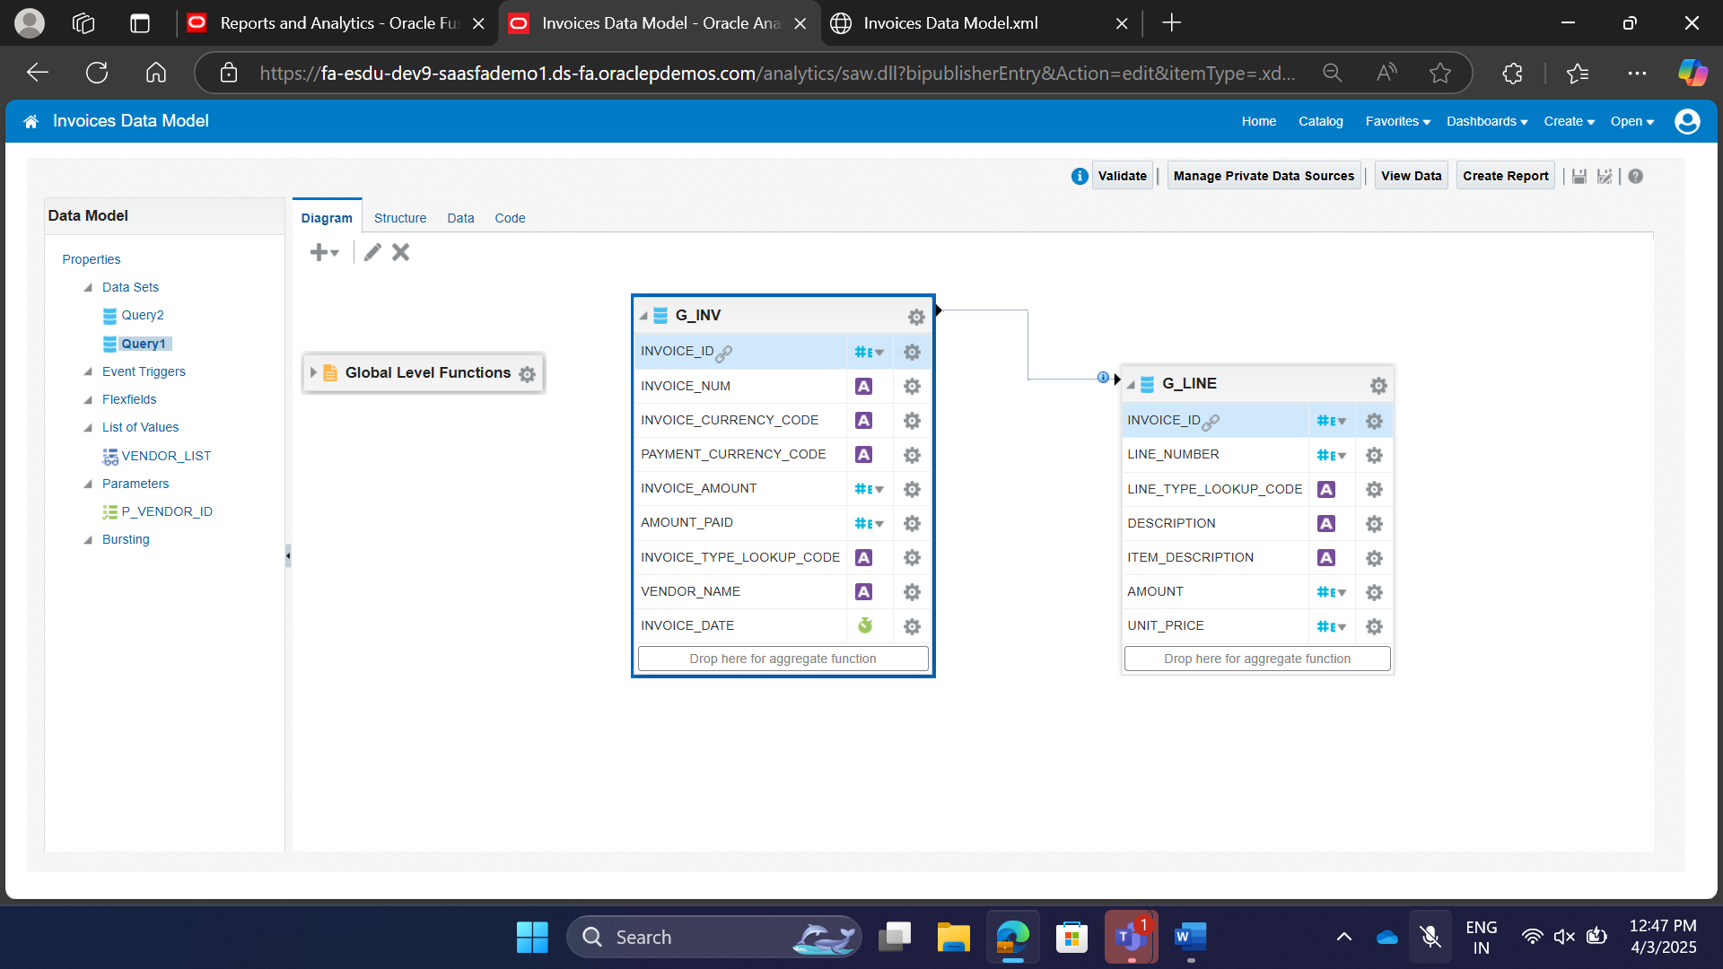

Create **Element by Expression, for the query result1, pay**

Drag Column from more detailed to overview part

Take Unpaid Amount

Invoice Amount

Invoice amount paid to the above, and

Invoice amount

Amount paid

Unpaid amount

Click **Add Element By Expression**

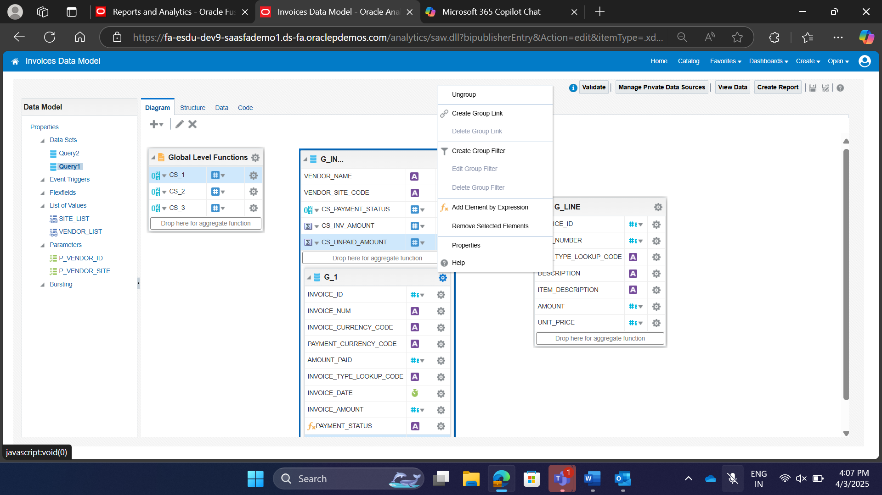  
**Condition for Payment Status:**

IF(G_INV.AMOUNT_PAID ==0, 'Unpaid', IF (G_INV.AMOUNT_PAID == G_INV.INVOICE_AMOUNT,'Paid', 'Partially Paid'))

**Condition for Unpaid Amount:**

G_INVOICE.INVOICE_AMOUNT-G_INVOICE.AMOUNT_PAID

**Multiselect Parameter**

**Query:**

Select vendor_site_code, vendor_site_id

from poz_supplier_sites_v

where vendor_id = :P_VENDOR_ID

create another **List of Value** named “SITE_LIST” with above query

And goto parameters for Vendor_site, enable the **Multiple Selection checkbox**, goto vendor id parameter, check the **Refresh other parameters on change**

**This Multiple Selection** will work for one-level parent to child relationship.

**Flexfield**

**BI Publisher** uses flexfield definition to dynamically consider the number of columns to display based on the flexfield definition.

To pick the structure instance number, use below query

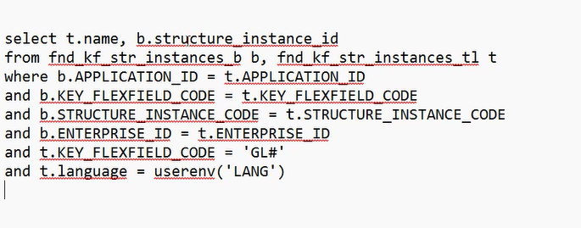

**Create a Data Model using below Query:**

select t.name, b.structure_instance_id

from fnd_kf_str_instances_b b, fnd_kf_str_instances_tl t

where b.APPLICATION_ID = t.APPLICATION_ID

and b.KEY_FLEXFIELD_CODE = t.KEY_FLEXFIELD_CODE

and b.STRUCTURE_INSTANCE_CODE = t.STRUCTURE_INSTANCE_CODE

and b.ENTERPRISE_ID = t.ENTERPRISE_ID

and t.KEY_FLEXFIELD_CODE = ‘GL#’

and t.language = userenv(‘LANG’)

select t.name, b.structure_instance_id

from fnd_kf_str_instances_b b, fnd_kf_str_instances_tl t

where b.APPLICATION_ID = t.APPLICATION_ID

and b.KEY_FLEXFIELD_CODE = t.KEY_FLEXFIELD_CODE

and b.STRUCTURE_INSTANCE_CODE = t.STRUCTURE_INSTANCE_CODE

and b.ENTERPRISE_ID = t.ENTERPRISE_ID

and t.KEY_FLEXFIELD_CODE = 'GL#'

and t.language = userenv('LANG')

**create a parameter as below:**

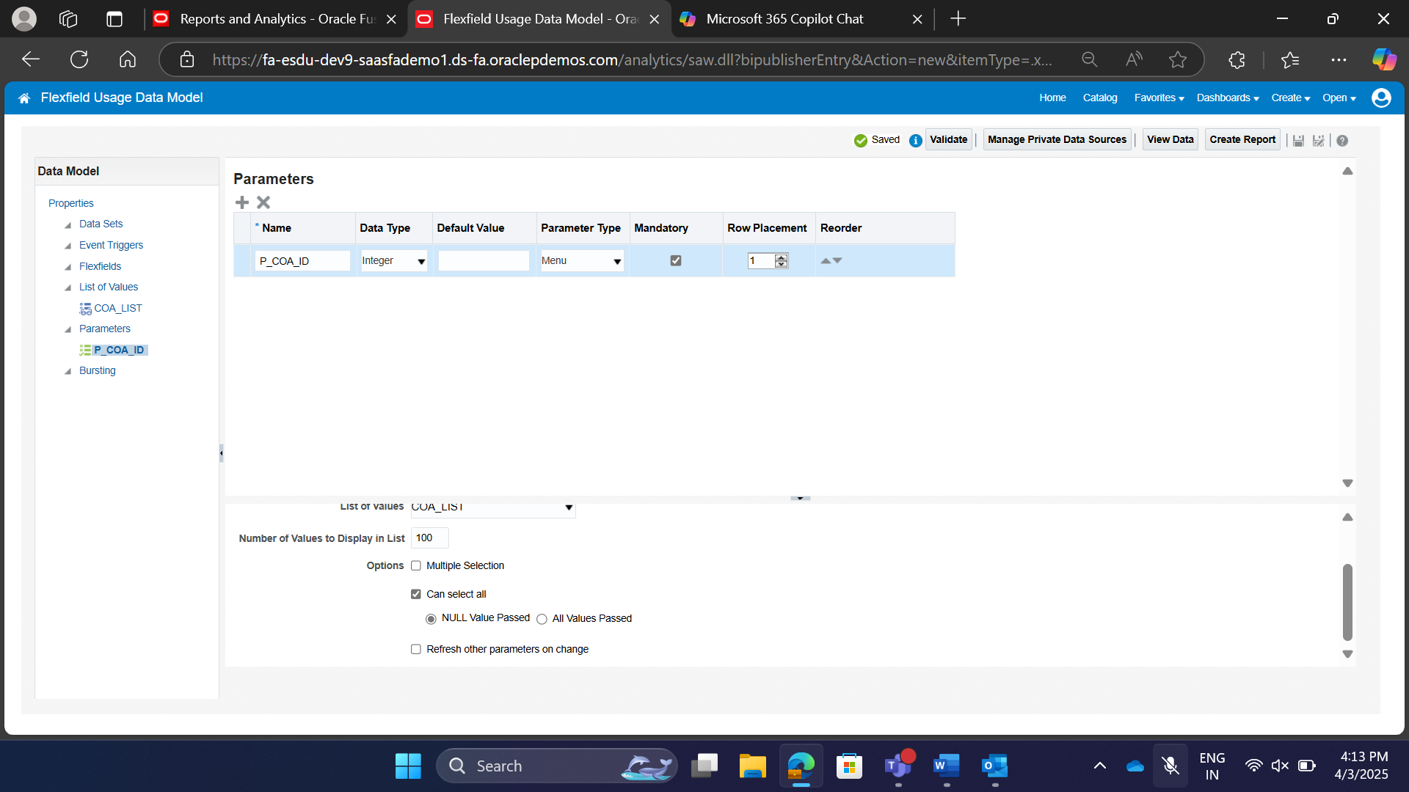

**General Ledger -> Tables -> GL_JE_HEADERS**

select h.je_header_id, h.je_category, h.je_source, h.currency_code, h.name, h.status

from gl_je_headers h, gl_ledgers l

where h.je_header_id = l.ledger_id

and l.chart_of_accounts_ID = :P_COA_ID

and exists (select 1 from gl_je_lines l where l.je_header_id = h.je_header_id)

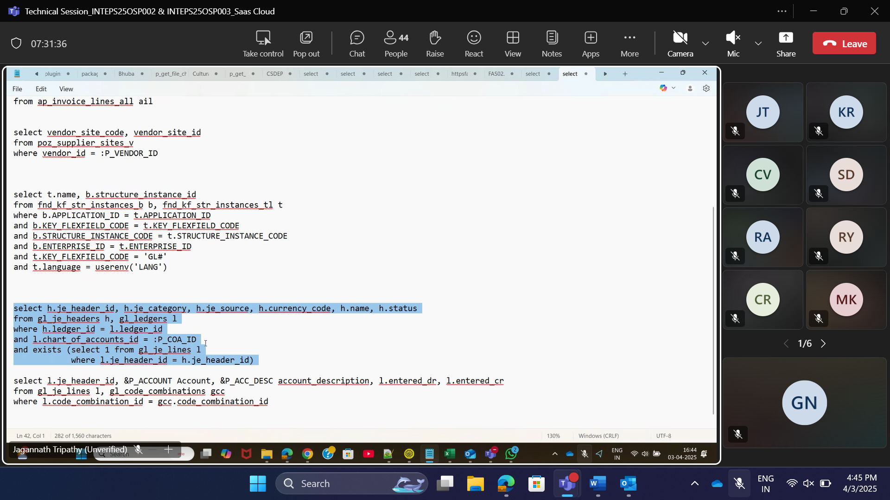

select l.je_header_id, &P_ACCOUNT Account, &P_ACC_DESC account_description, l.entered_dr, l.entered_cr

from gl_je_lines l, gl_code_combinations gcc

where l.code_combination_id = gcc.code_combination_id

**Lexical used to display the columns dynamically.**

**Merge above two queries:**

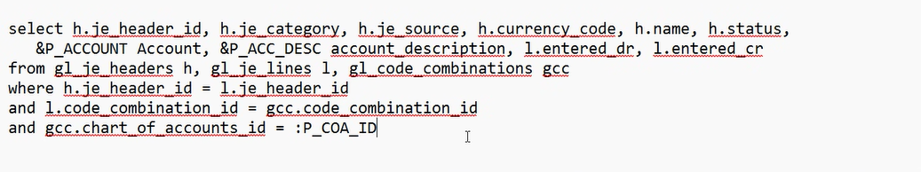

select h.je_header_id, h.je_category, h.je_source, h.currency_code, h.name, h.status, &P_ACCOUNT Account, &P_ACC_DESC account_description, l.entered_dr, l.entered_cr from gl_je_headers h, gl_je_lines l, gl_code_combinations gcc

where h.je_header_id = l.je_header_id

and l.code_combination_id = gcc.code_combination_id

and gcc.chart_of_accounts_id = :P_COA_ID

and h.creation_date > sysdate-100

C:\Program Files\Oracle\BI Publisher\BI Publisher Desktop\Template Builder for Word\doc

**Dashboard:**

User input parameter is called **Prompt.**

Under **Dashboard Prompt**, create a column prompt

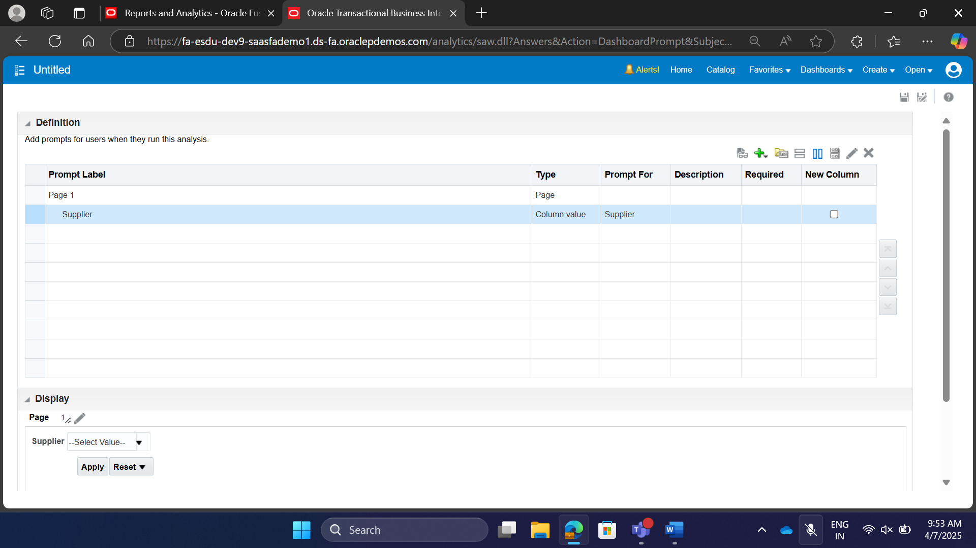

**Transfer the reports to shared folder of another instance:**

All the reports should be filtered by the supplier folder

We can’t create dashboards in My Folder. So, Move all the reports to shared folder.

If we want to share among the instance, create a archive file(catalog file) for that report(individual or folder containing reports)

Goto shared folders, in shared folders, you should create in **custom** directory, remaining are standard reports provided by Oracle.

Create a folder in the custom directory, Then unarchive the file(catalog file should be unarchived).

**Create a Dashboard:**

Goto the custom folder, in that create new Folder

In the newly created folder, create a dashboard.

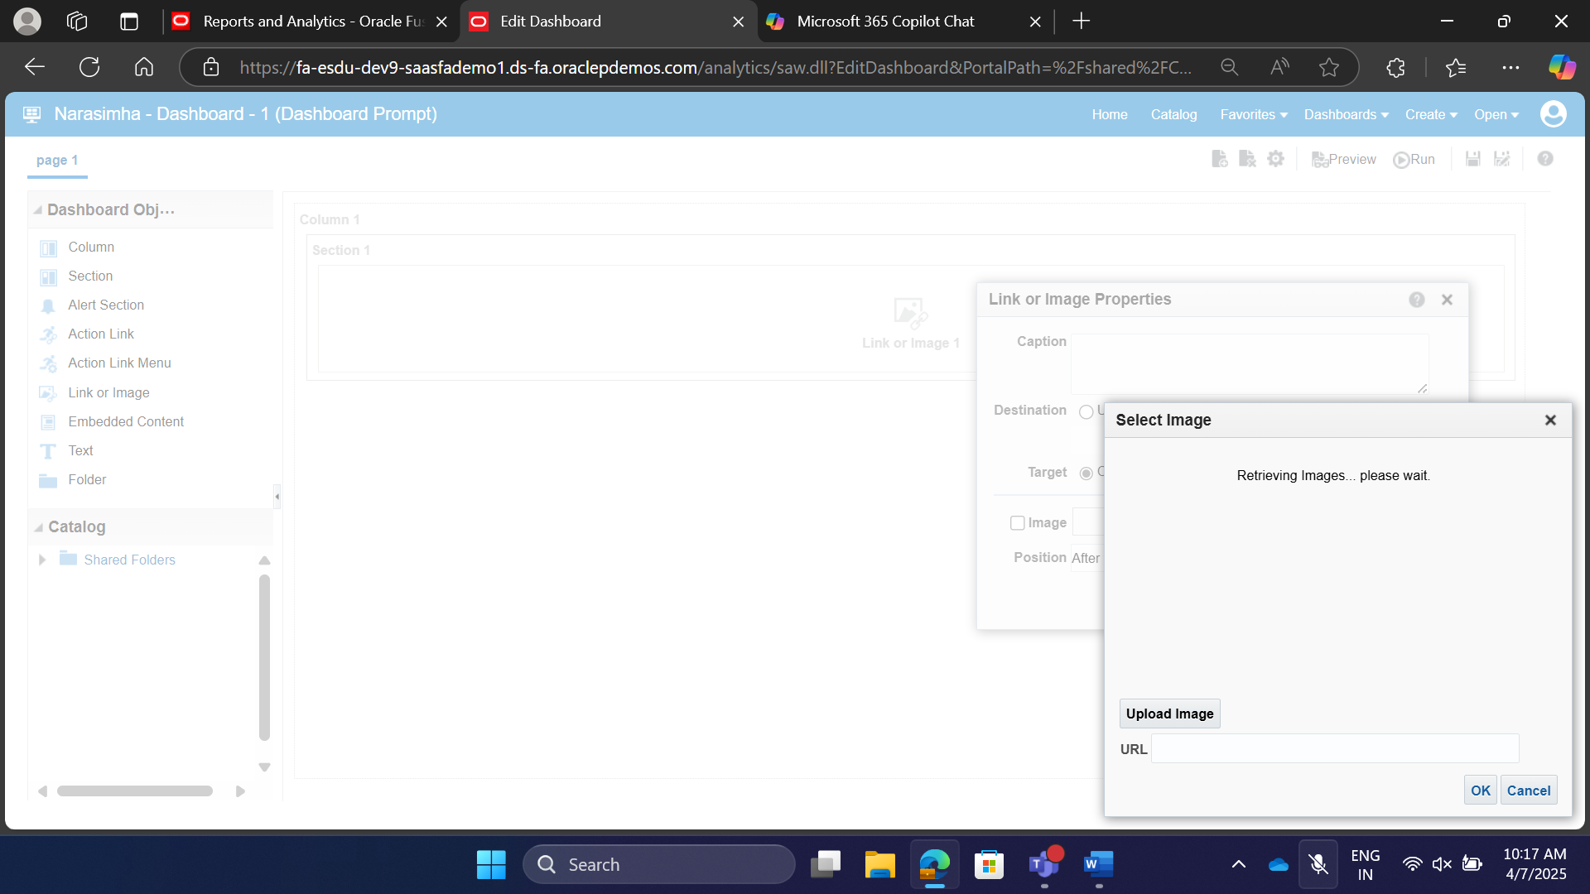

Insert a Column.

In the column, insert section, and inside the section add the Link or Image.

If images are not loading, use any image url and then save and run the dashboard, then repeat the step from the column, section , link or image.

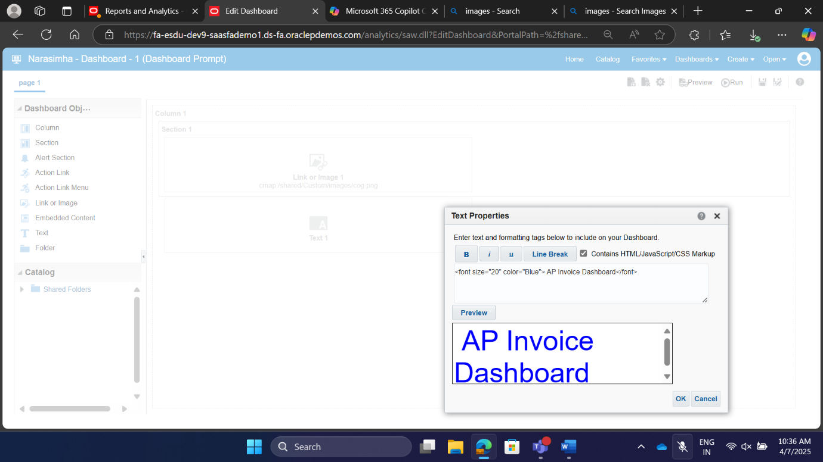

Then drag and drop the text on to the right side of the image, but still it appears below the image, but in dashboard it appears on the image.

Then check the contains HTML/JavaScript/CSS Markup checkbox, then write code in the image.

In the Catalog section, under shared folders, navigate to the dashboard prompt drag it to the right side of the text.

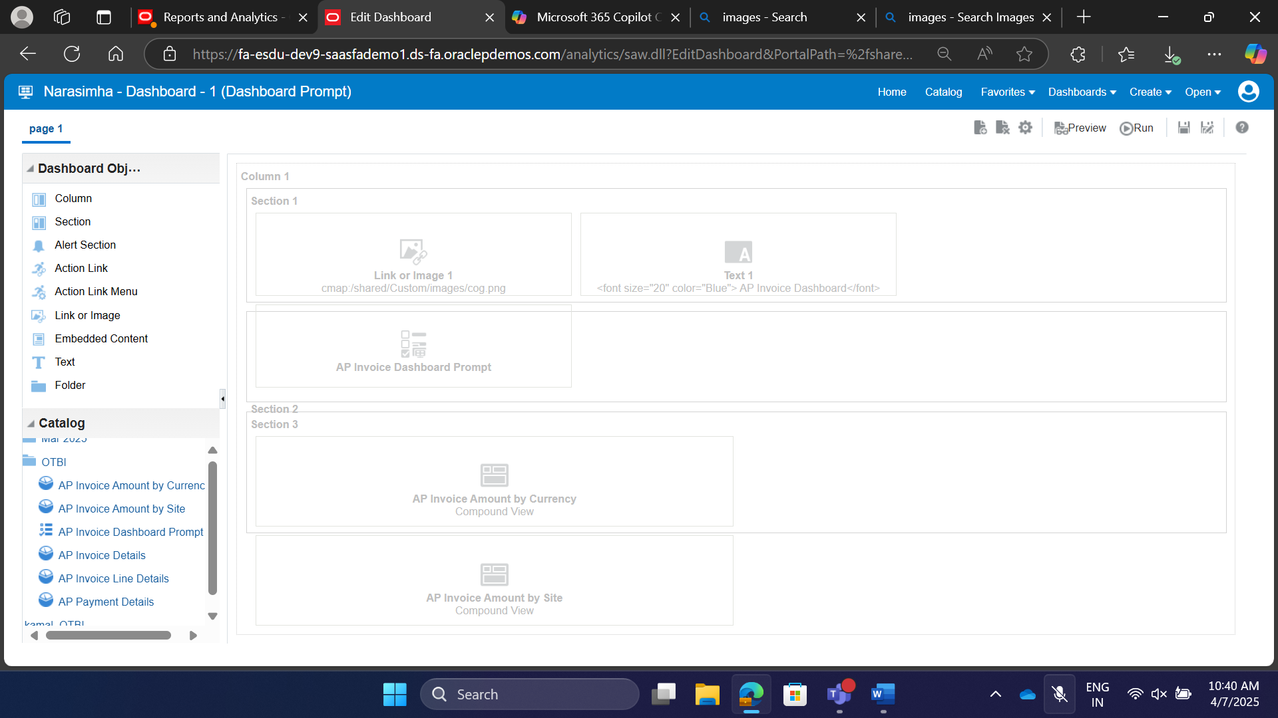

Put the section 2, and in that section 2 add AP Invoice Amount by Currency, and AP Invoice Amount by site to the right of AP Invoice Amount by Currency.

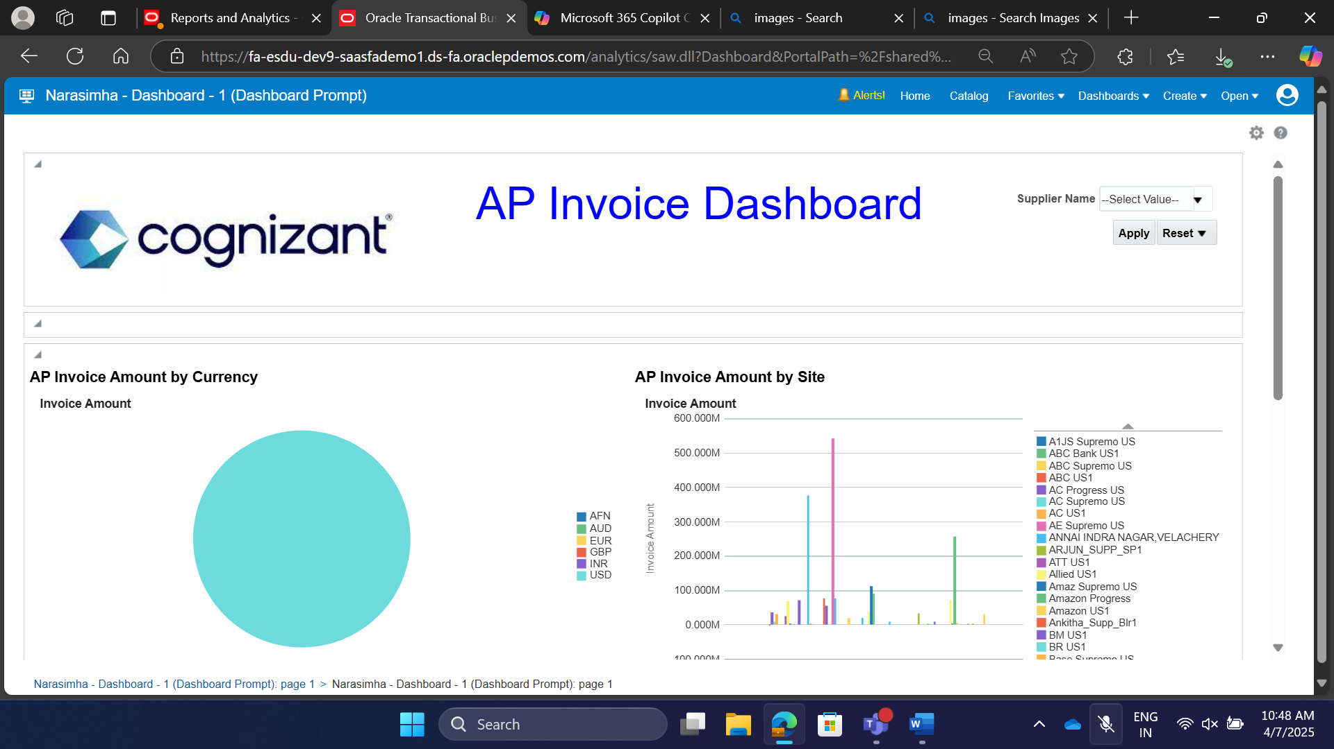

Save the Dashboard and click Run.

**Pivot Table** shows correlations between two columns(two of the dimensions).

To create a pivot table, we need two dimensions and one fact.

Use Invoice Amount, under Invoice Amounts and Invoice Currency and Invoice Type Name from Invoice Details, save the Pivot table, then goto result, create a view (pivot table)

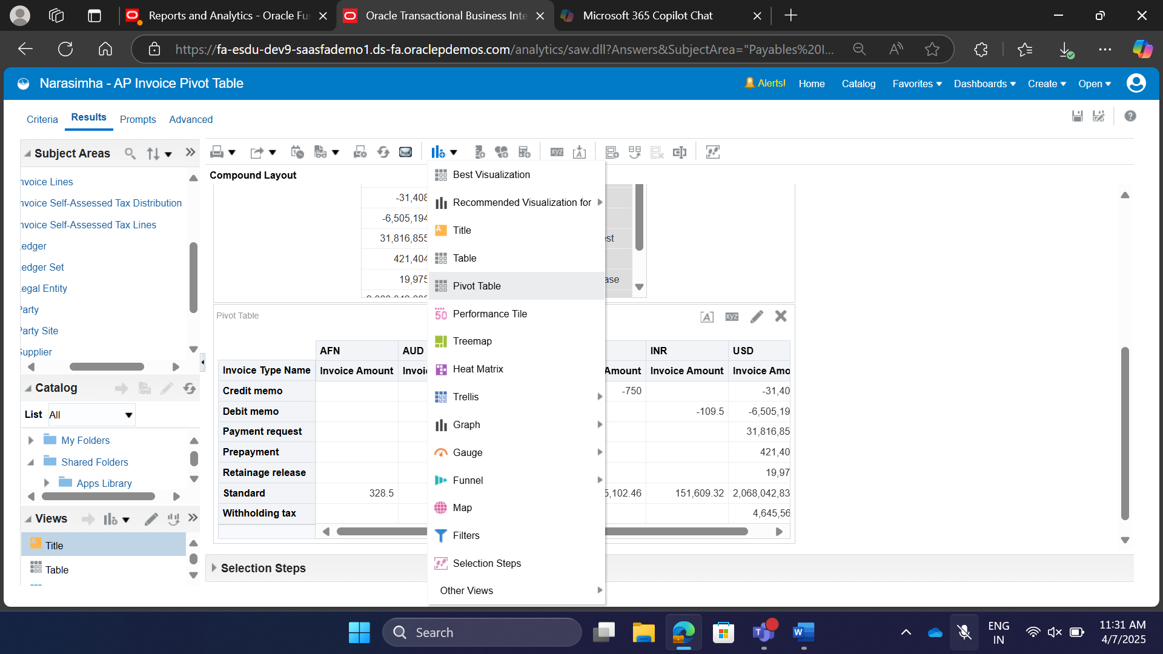

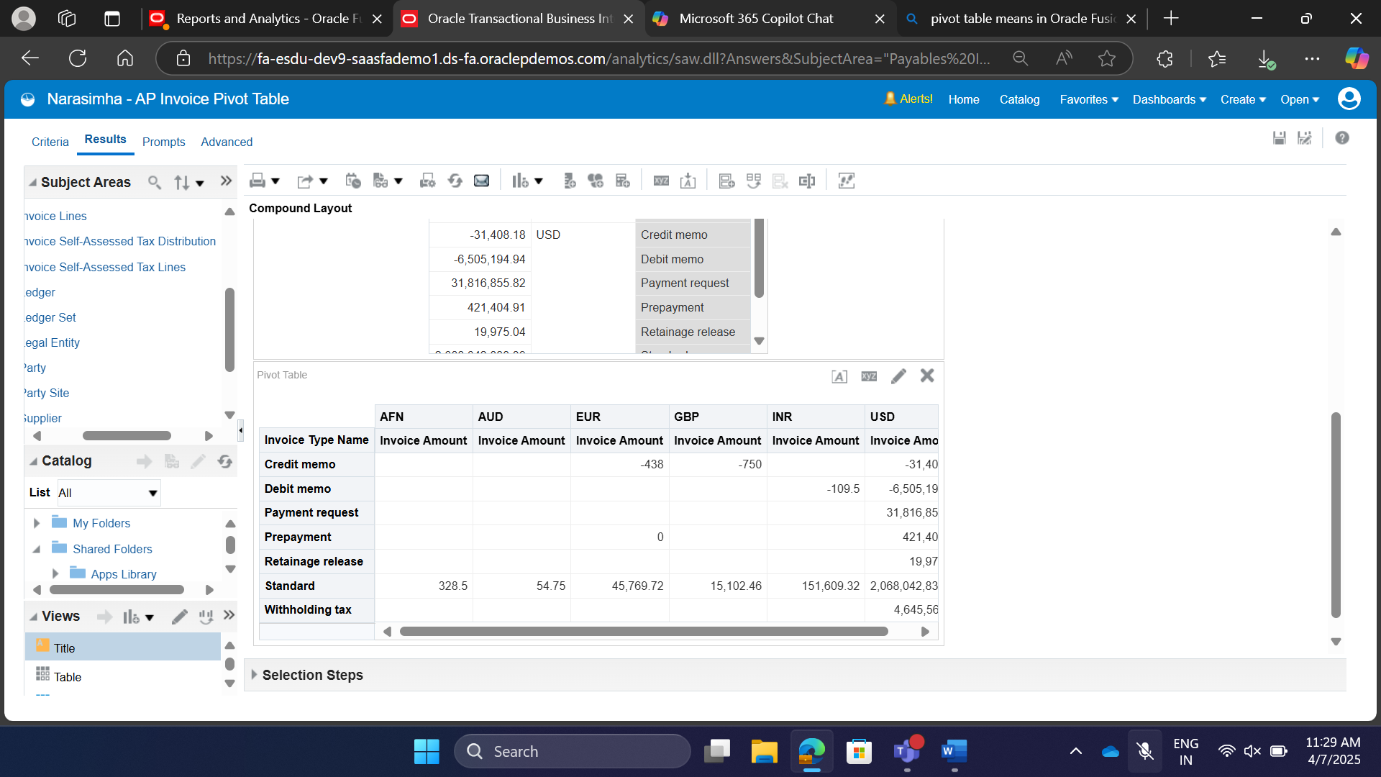

When the dimension has number of unique values are less, use that dimension as column, if the number of unique values are more, then use it as a row.

**Heat Map**

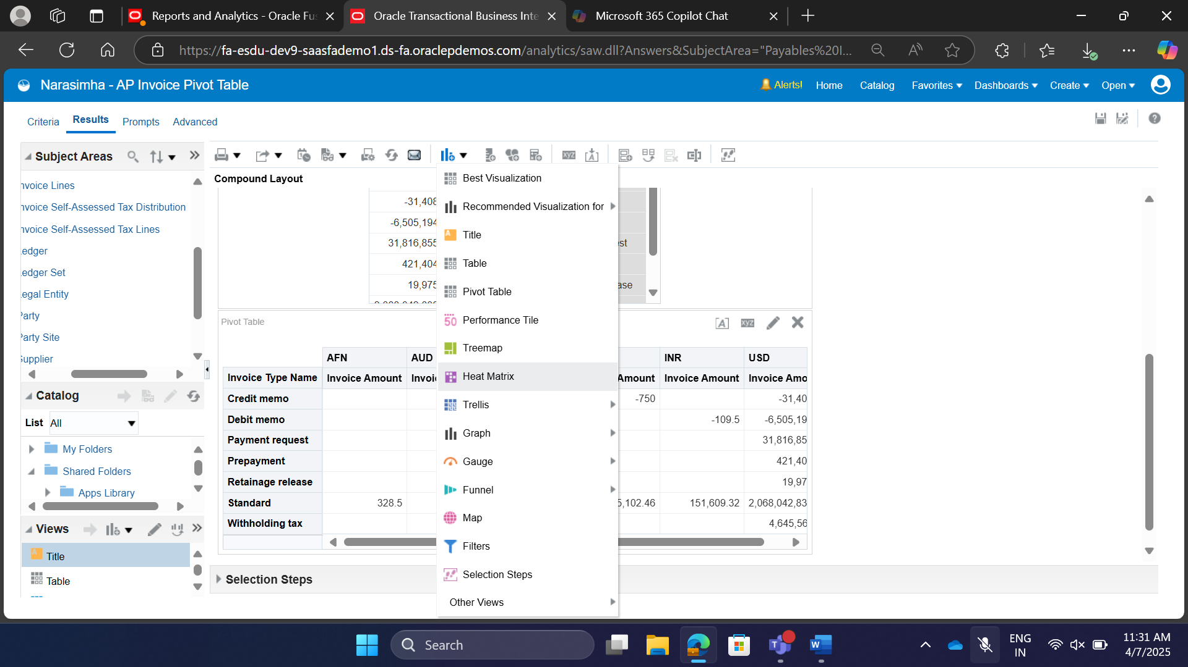

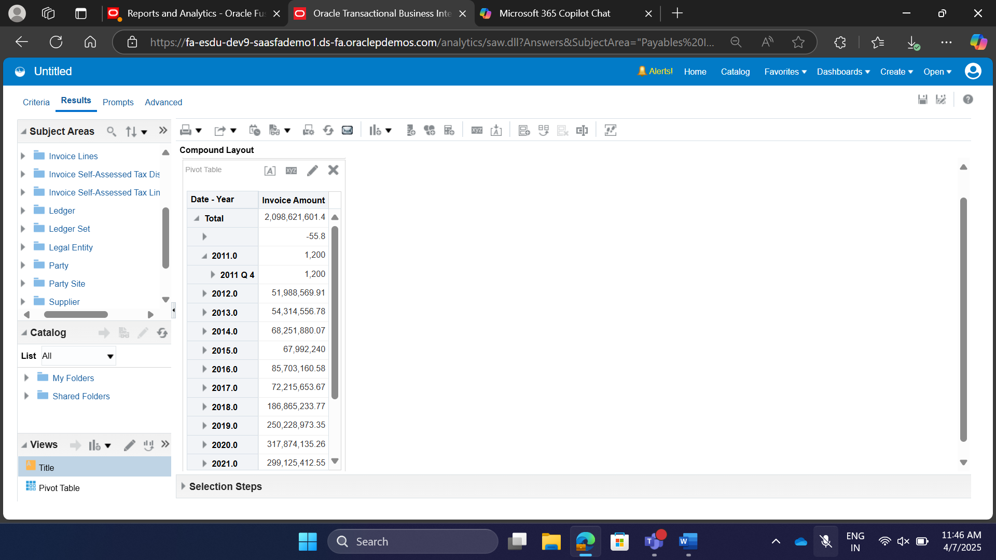

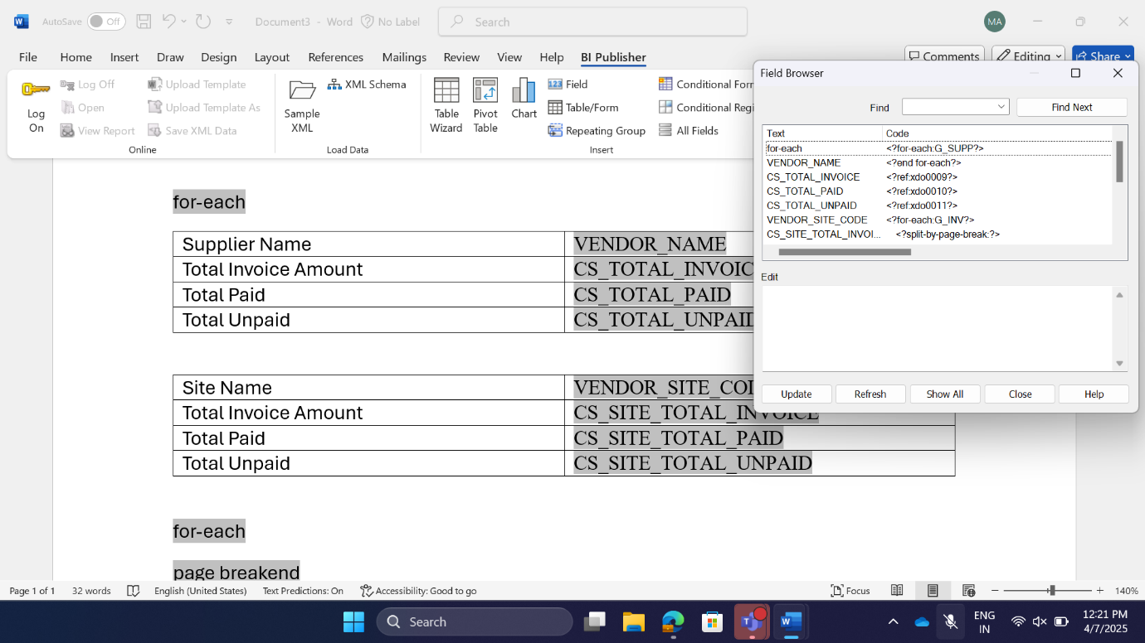

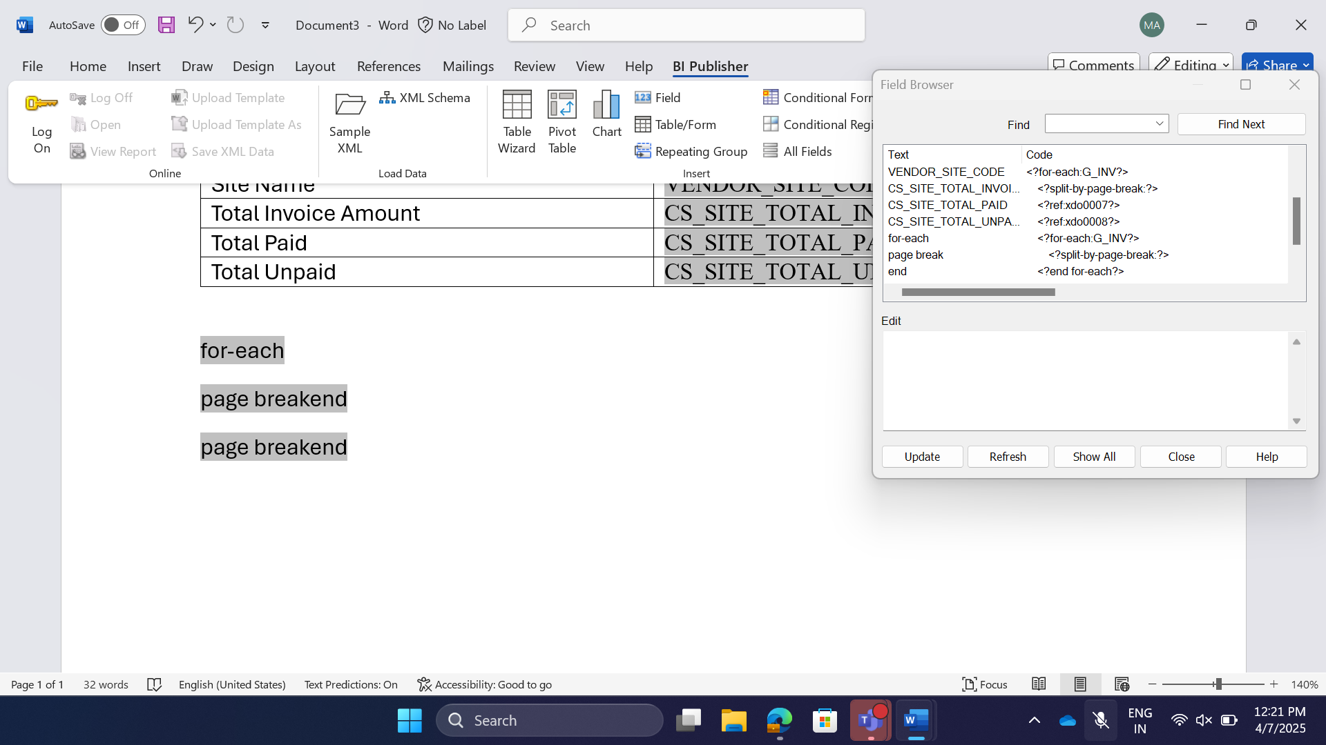

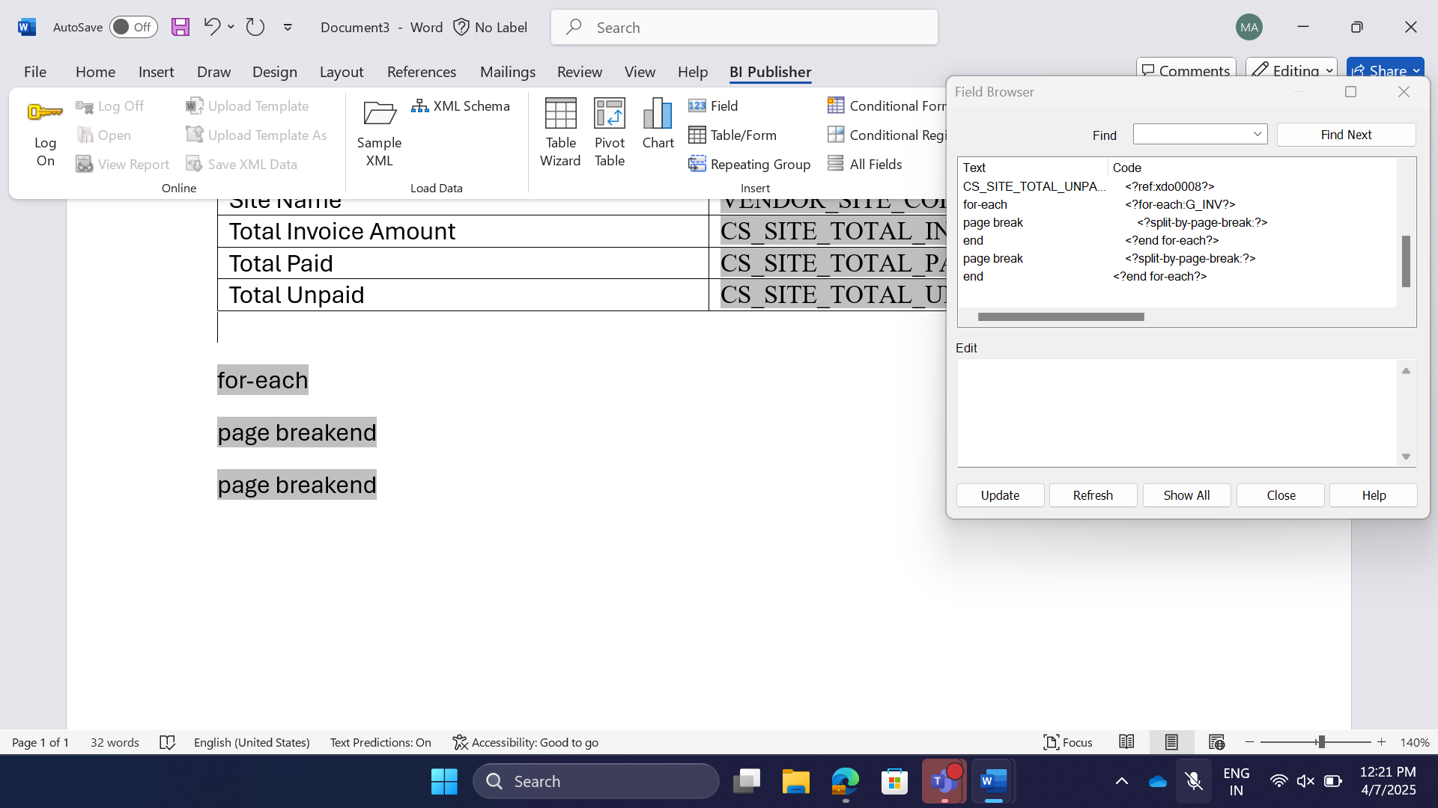

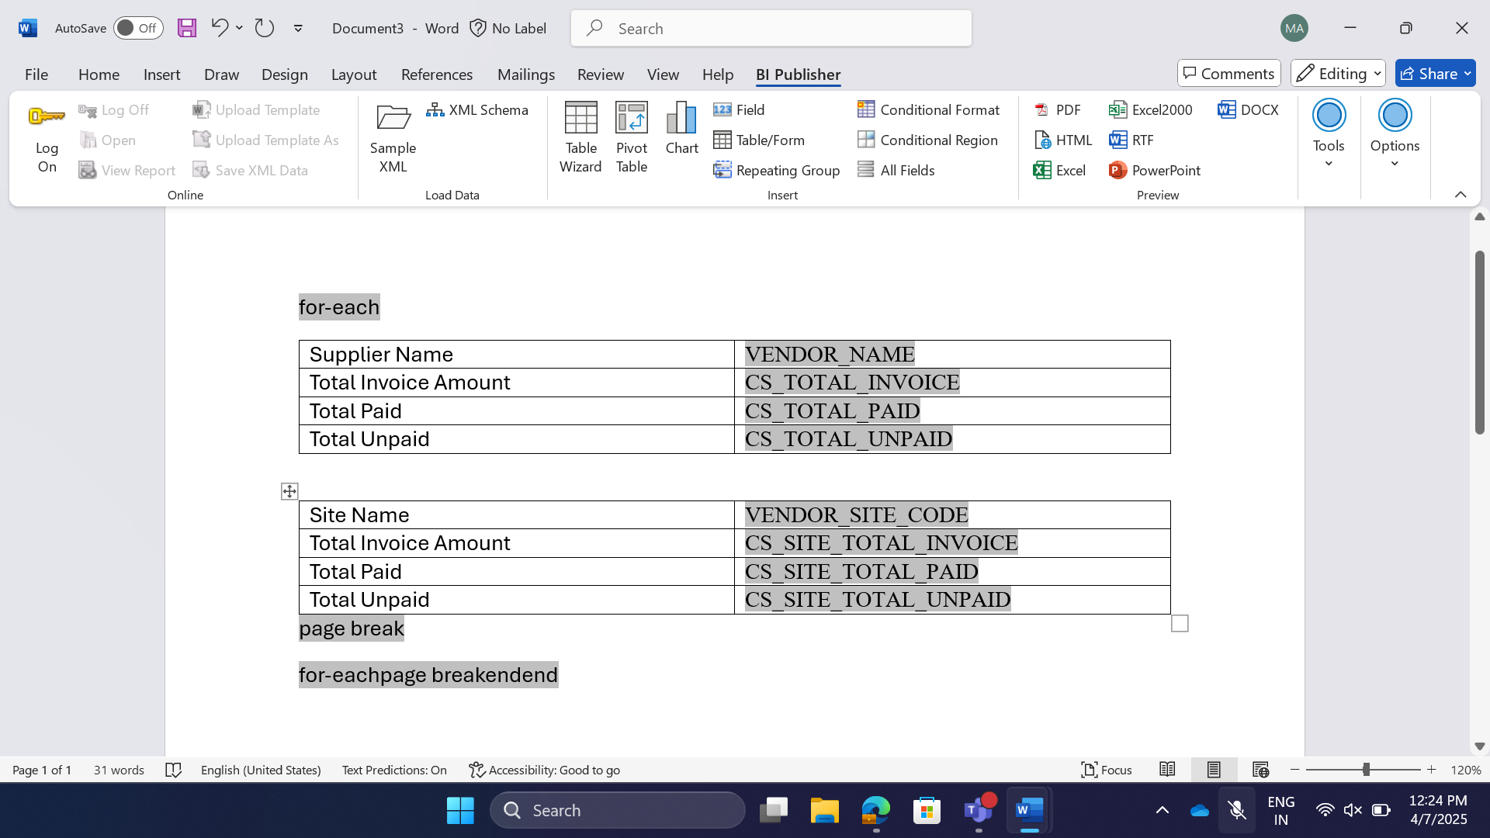

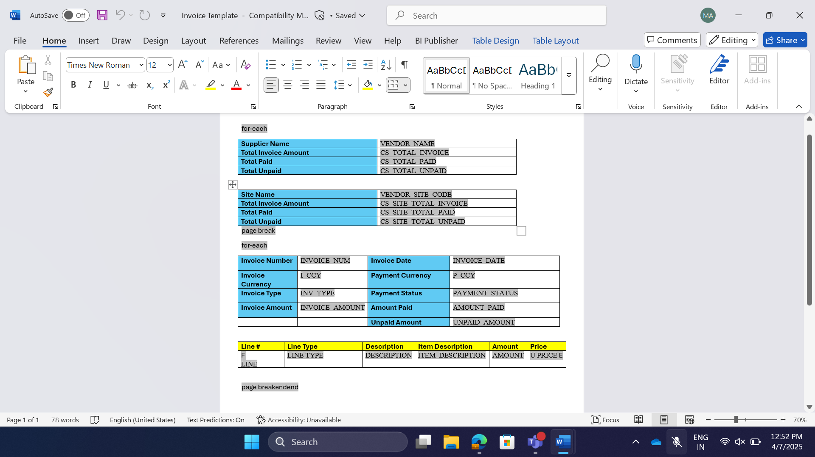  
Final Template should look like above

Search for the data model and then submit the above rtf file in the corresponding data model.(Under Catalog -> Report)

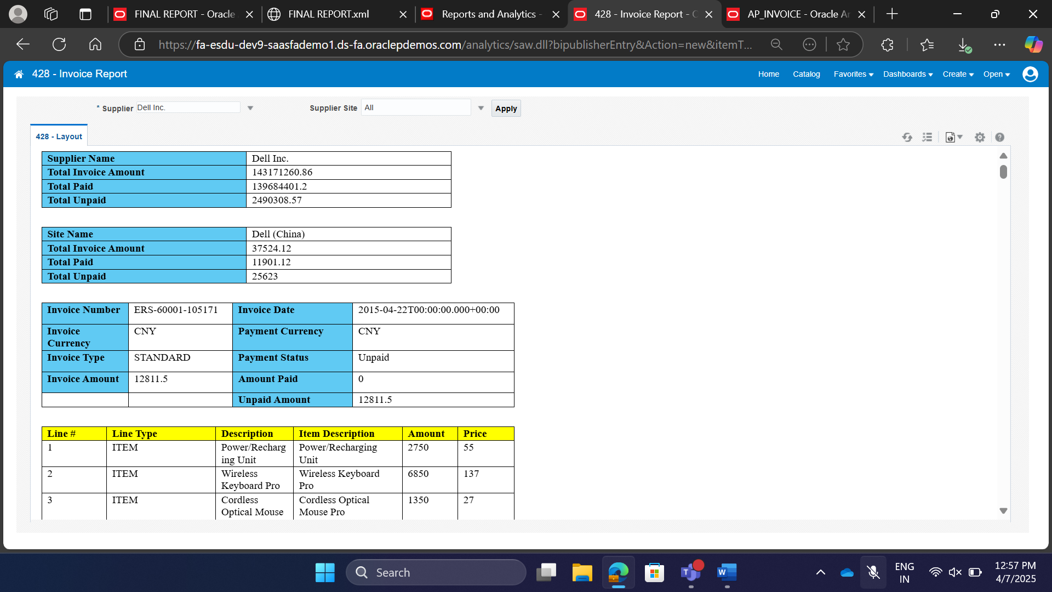

**Distribution**

For distribution we should perform Splitting and Delivering the report. Every Split will be delivered to the user. Reason to split is, every receiver should receive only desired data.

Splitting in BI Publisher means **Bursting.**

Splitting is based on Key Column. Every Split should contain only one Deliverable Key (Highest Level).

e.g. Person Number

Open the Data Model

Under the Bursting (left bottom).

Select Split by and Deliver by.

Output will be in Html, pdf, RTF, XML, CSV etc.

Where XML and CSV are independent of template. But the template should be present.

**Bursting Query:**

Select invoice_id key,

‘T3’ template,

‘en_US’ locale,

‘true’ save_output,

‘EMAIL’ del_channel,

‘APINV’ || invoice_id || ‘.pdf’ output_name,

‘jagannath.tripathy2@cognizant.com’ parameter1, --To

‘’ parameter2,

‘oracle_fusion_team@cognizant.com’ parameter3, --From

‘Invoice ’ || invoice_num || ‘ details’ parameter4, --Subject

‘Hi, ‘ ||

(select vs.vendor_site_code

From poz_supplier_sites_v vs

Where vs.vendor_site_id = ai.vendor_site_id)

|| ’,

Please find the details for invoice ’ || invoice_num || ‘attached.

Thanks

Oracle Fusion Team’ parameter5, --body

‘true’ parameter6, -- attachment

‘oracle_fusion_team@cognizant.com’ parameter7, --REPLY_TO

‘’ parameter8 --bcc

From ap_invoices_all

We can send the notifications regarding reported succeeded or failed to the team using Notifications.

Diagnostics are used to log the details. Used in development environment.

We can enable individual diagnostics.

Every deliver channel have its parameters.

**Customize the Standard/Seeded Reports**

Seeded Reports are predefined reports that runs in Enterprise Scheduler Service Job.

Goto Schedule Processes -> Schedule a new Process -> Payables Invoice(Report name) -> Payables Invoice Register -> select Business Unit and Supplier, -> Goto Advanced Options -> Goto Output Tab -> add the output(output name, format) -> submit.

Republish.

To find the Predefined Reports, First we need to find the Report ID in the “Payables Invoice Register” Process

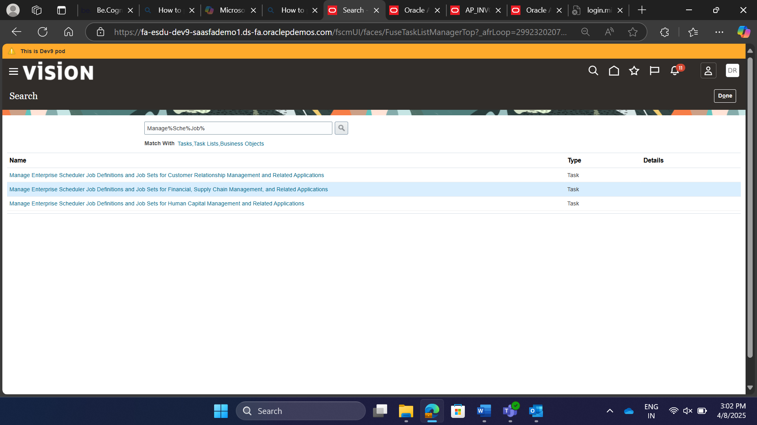

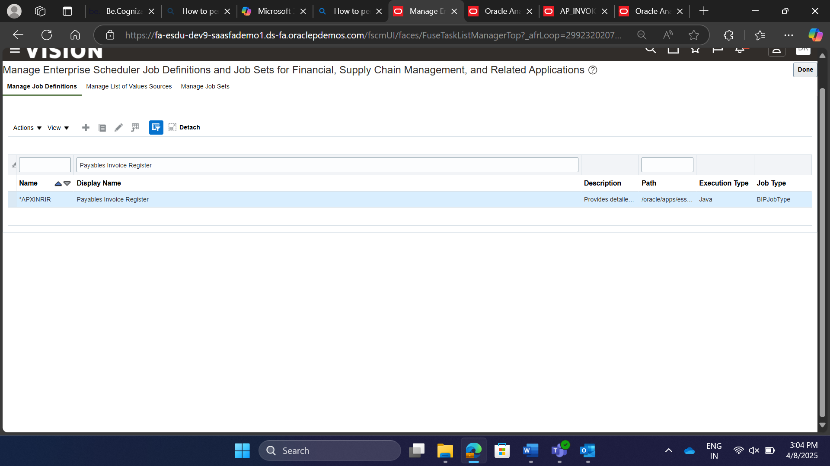

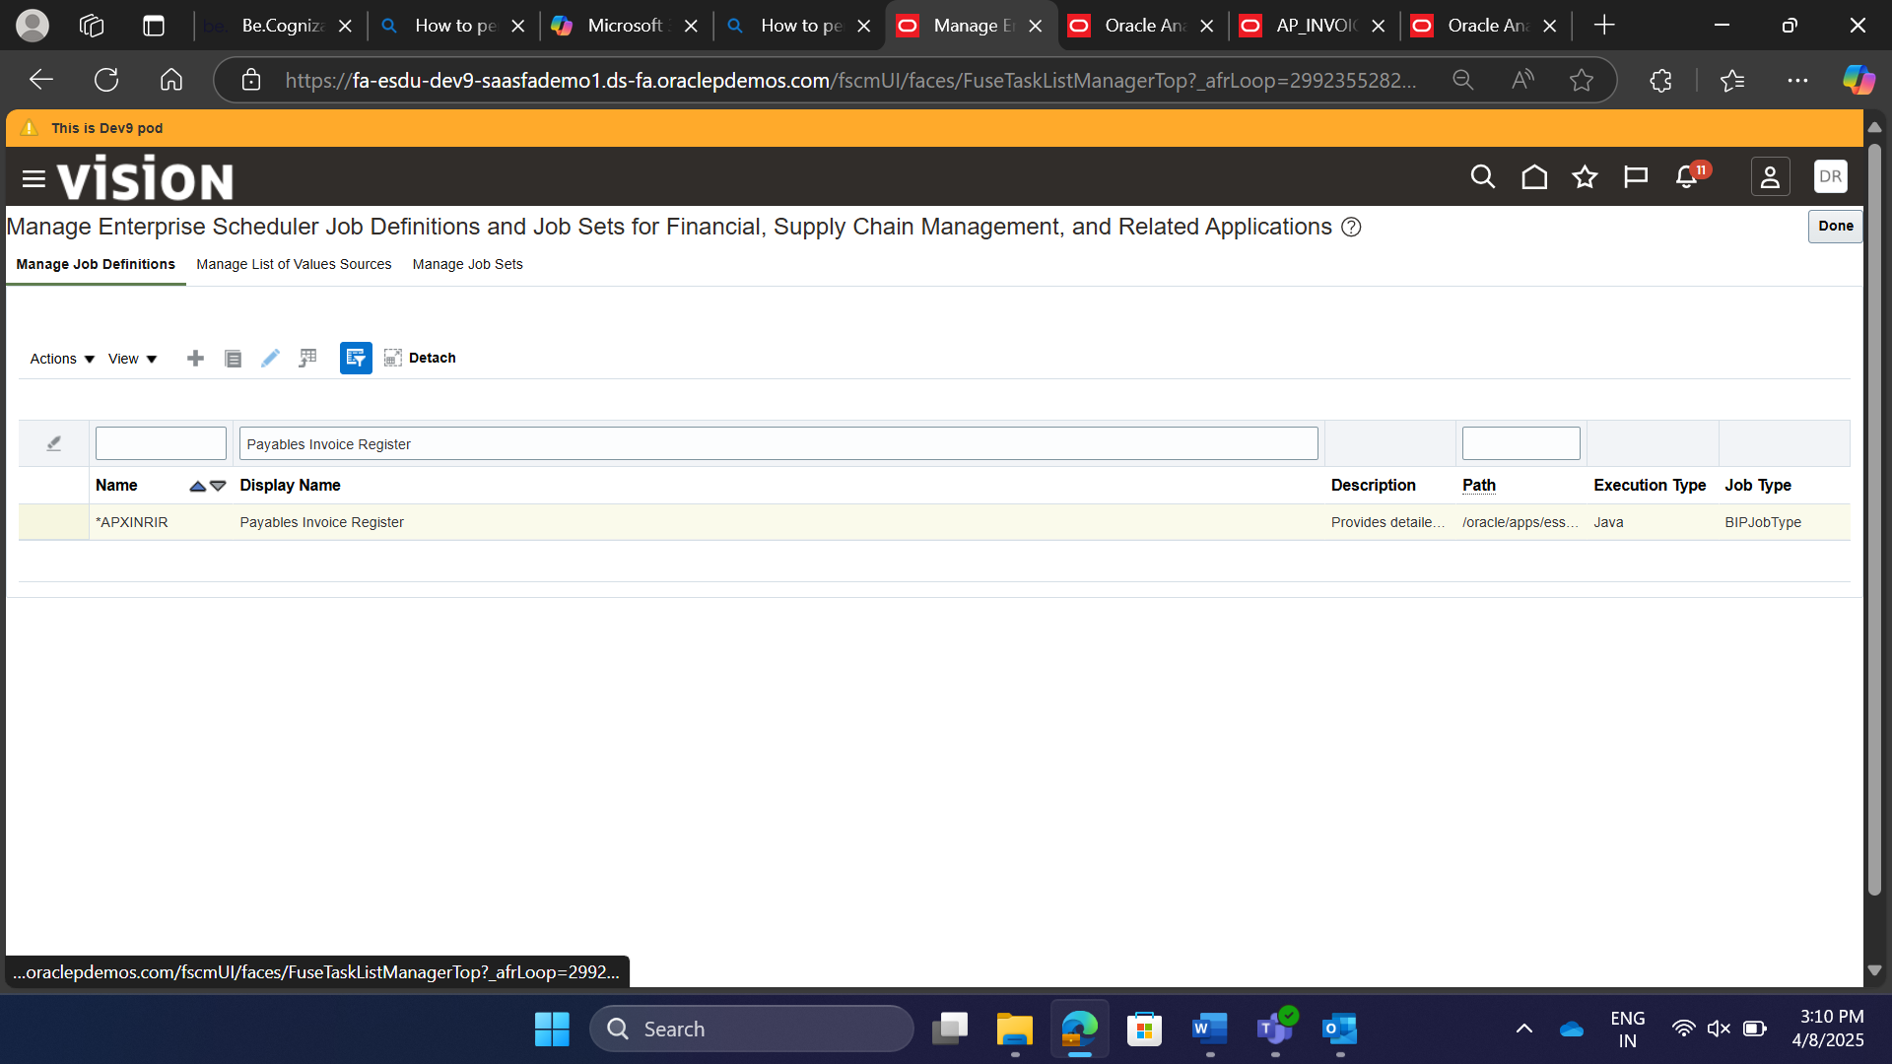

Report ID for New Process We Scheduled: /Financials/Payables/Invoices/InvoiceRegister.xdo

* + 1. Shared Folders->Finanicals->Payables-> Invoices -> “Payables Invoice Register” Report
    2. Shared Folders->Finanicals->Payables-> Invoices -> Data Models -> “Payables Invoice Register Data Models”

Copy above 1 and 2 in to your folder in the Shared Folders.

Edit the Data Model. Goto Properties. Upload sample data (upload the xml we downloaded at the output of Payables Invoice Register Process)

Catalog -> Open “Payables Invoice Register” Report, click search icon and change the data model to the data model that existed in the custom saas(our folder)

Catalog -> Open Payables Invoice Register Report, then click Edit.

Report Path: /oracle/apps/ess/financials/payables/invoices/transactions/

PKG Name: oracle.xdo.service.client.scheduler.BIPJobExecutable

Display Name, Name, Path, Report ID

**FRS – Financial Reporting Solution (Data Warehouse)**

Schedule the purge program to delete.

Name of the database: ESSBase

We need to create and schedule a job, to transfer the data from online DB to Warehouse.

Fact (Account Balance) and multiple Dimensions.

Task:

Others, Financial Reporting Center, All, tasks Panel, 2nd link, if popup is blocked enable it, Launch Financial Reporting Web Studio, click new, new report, insert grid (grid queries the data from database), Database Connection Properties, Dimension Layout grid, drag account into rows, Business area into Columns, Accounting Period to the area, save the report in a new folder. Insert, column data, Select Memebers, If a report job is already scheduled

BIP has four Abstract roles.

BI Consumer role to read models.

BI Author creates or edit reports, cannot create or edit data models.

BI Data Model Developer BI Author + Can create or edit data models.

BI Administrator he can do anything including system/server level setups.

Access Control Lists (ACL): This can be attached to report or to anyone of the individual data model. ACLs can be given at user level or Role. If it is added to the user, then it is having the higher priority.

Business Units is part of the enterprise where actual business of the enterprise will be performed, it is responsible for its own profit and loss, processes transactions on behalf of Legal Entities.

Legal Entity is nothing but an Organization where company is legally registered.

Legal Employer is also an Legal Entity which is responsible for hiring employees.

Payroll Statutory Unit is also an Legal Entity which is responsible for paying workers and payroll tax.

Legislative Data Group is used for payroll partitioning (allocating different cost allocatin structure and currency) for different PSUs.

Divisions are partitions of Enterprise, through which profit and loss can be divided among different countries.

Enterprise is a company which perform commercial activities backed by initiative and resourcefulness.

Grades are levels used for career progression(promoting an employee, salary hike)

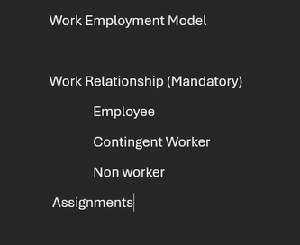

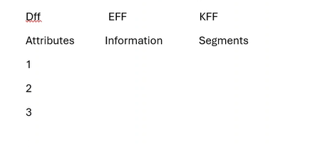

Payroll elements are element (Salary, incentives) and deducting element (Income tax, PF).

Elements are categorized as recurring (Elements that can be processed every month) and Non-recurring (Elements that are processed that once or random basis).

Elements may/may not be processed with the payroll. (Loan, EMI)

Loan is the earning element non-recurring processed along with payroll.

EMI is the deducting element recurring processed along with payroll.

Transaction data is attaching the elements use 1st Jan 1951, set up data is creation of elements for that use todays data.

**Pay value:** A number/money (datatype is money) which is getting paid every month.

We need fast formula for calculations.

**Fast Formula:**

Fast Formula is a feature that allow to create custom logics/formulas using simple English words and mathematical functions.

**Components of Fast Formulas:  
Formula Types** are used to specify the scope of fast formulas based on where it will be used in the application. e.g. select extract rule as formula type, to attach it with the Extract Rule of Data Group.

**Contexts** are pre-defined variables that provide information about the environment in which the fast formula is executed. They can be provided while executing the fast formula. e.g. payroll ID, Effective Data, source of the database item can also be provided in this context.

**Input values** are the parameters that were passed into the fast formula. They can be user defined, or system defined. Input values are similar to context, but the difference is input values are not pre-defined.

**Database Items** are the predefined elements that were retrieved from the database.

**Route** is the source of the database item. In simple Terms, it is nothing but table name within which the database items exist.

**Functions**

**User Entities**

**Return Variable** is a single parameter which returns a value to the rule of the data group record.

**Fast Formula:** Oracle payroll engine executes the formula

You can have four types of variables,

* + 1. Context is the id for which the formula is running. (Person ID, Assignment ID, Payroll Period Start/End Date)
    2. Database Items are what you query from the database using context. Database items should be default.
    3. Inputs are the parameters that are passed to the formula. Parameter passing is optional from both sides.
    4. Local Variables

/*********************************************

*********************************************/

DEFAULT FOR PER_PER_SEX IS ‘M’

DEFAULT FOR PER_PER_MARITAL_STATUS IS ‘S’

DEFAULT FOR PER_PER_PERSON_NUMBER IS ‘O’

INPUTS ARE Base_Amount

l_factor = 1

IF (PER_PER_SEX = ‘M’) THEN (

IF (PER_PER_MARITAL_STATUS = ‘S’) THEN (

l_factor = 1

)

ELSE (

l_factor = 1.5

)

)

ELSE (

IF (PER_PER_MARITAL_STATUS = ‘S’) THEN (

l_factor = 1.1

)

ELSE (

l_factor = 1.6

)

)

l_pay_val = BaseAmount * l_factor

l_message = 'Calculated Transport Allowance for '|| PER_PER_PERSON_NUMBER

|| ' Gender ' || ' Marital Status' || PER_PER_MARITAL_STATUS || ' is ' || to_char(l_pay_val)

return l_pay_val, l_message

**Retroactive Changes:** Change(Increase or Decrease in Salary) in payment, that can be paid afterwards than the actual date of payment(Increased or Decreased Amount).

**Creating Payroll Element:**

Login with hcm user, my client groups, show more, elements, IN LDG, Earnings, Standard Category, Effective start Date as 1/1/1951

Select the element, click correct, change effective as of date to “1/1/1951”

`

**Important Navigations in Oracle Fusion HCM:**

**Hire an Employee:** My Client Groups, Hire an Employee (Quick Actions)/New Person, select an employee.

**Promote and Demote an Employee:**

My Client Groups, Show more, Promote

My Client Groups, Person Management, search for the person, click on person name, Click edit drop down, then click update, (then under for local transfer click Transfer OR for Global Transfer click Global Transfer OR for Promotions Click Promotion OR for Demotion click Demotion)

|  |  |
| --- | --- |
|  |  |

**Terminate an Employee:** My Client Groups, Person Management, search for the person, click on person name, click the tasks panel icon, then click work relationship, then click under actions dropdown, click Terminate.

**Rehire an Employee:** My Client Groups, Person Management, search for the person, Actions, create work relationship, under actions dropdown select rehire an Employee, if required you can enter Action reason as “Rehire to fill vacant Position”.

**Important Columns in Key Tables**

**1. FOR_ALL_PEOPLE_F**

* **PERSON_ID**: Unique identifier for the person.
* **PERSON_NUMBER**: Employee number.
* **EFFECTIVE_START_DATE**: Start date of the record.
* **EFFECTIVE_END_DATE**: End date of the record.
* **DATE_OF_BIRTH**: Date of birth of the person.
* **GENDER**: Gender of the person.

**2. PER_PERSON_NAMES_F**

* **PERSON_ID**: Unique identifier for the person.
* **NAME_TYPE**: Type of name (e.g., GLOBAL, LANGUAGE_CODE).
* **FIRST_NAME**: First name of the person.
* **LAST_NAME**: Last name of the person.
* **EFFECTIVE_START_DATE**: Start date of the record.
* **EFFECTIVE_END_DATE**: End date of the record.

**3. PER_ALL_ASSIGNMENTS_M**

* **ASSIGNMENT_ID**: Unique identifier for the assignment.
* **PERSON_ID**: Unique identifier for the person.
* **JOB_ID**: Identifier for the job.
* **POSITION_ID**: Identifier for the position.
* **EFFECTIVE_START_DATE**: Start date of the record.
* **EFFECTIVE_END_DATE**: End date of the record.

**4. PER_ADDRESSES**

* **ADDRESS_ID**: Unique identifier for the address.
* **PERSON_ID**: Unique identifier for the person.
* **ADDRESS_LINE1**: First line of the address.
* **ADDRESS_LINE2**: Second line of the address.
* **POSTAL_CODE**: Postal code of the address.

**5. PER_ADDRESS_USAGES**

* **ADDRESS_USAGE_ID**: Unique identifier for the address usage.
* **PERSON_ID**: Unique identifier for the person.
* **ADDRESS_ID**: Identifier for the address.
* **USAGE_TYPE**: Type of address usage (e.g., permanent, temporary).

**6. PER_ASG_SUPERVISORS_F**

* **SUPERVISOR_ID**: Unique identifier for the supervisor.
* **PERSON_ID**: Unique identifier for the person.
* **ASSIGNMENT_ID**: Identifier for the assignment.
* **MANAGER_TYPE**: Type of manager (e.g., LINE_MANAGER).

**7. HR_ALL_ORGANIZATION_UNITS**

* **ORGANIZATION_ID**: Unique identifier for the organization.
* **NAME**: Name of the organization.
* **BUSINESS_GROUP_ID**: Identifier for the business group.

**8. HR_ALL_ORGANIZATION_UNITS_TL**

* **ORGANIZATION_ID**: Unique identifier for the organization.
* **LANGUAGE**: Language code.
* **NAME**: Name of the organization in the specified language.

**9. PER_JOBS_F**

* **JOB_ID**: Unique identifier for the job.
* **JOB_CODE**: Code for the job.
* **JOB_NAME**: Name of the job.

**10. PER_JOBS_F_TL**

* **JOB_ID**: Unique identifier for the job.
* **LANGUAGE**: Language code.
* **JOB_NAME**: Name of the job in the specified language.

**Tables Updated During Employee Lifecycle Events**

**1. Hire**

* **FOR_ALL_PEOPLE_F**
* **PER_PERSON_NAMES_F**
* **PER_ALL_ASSIGNMENTS_M**
* **PER_ADDRESSES**
* **PER_ADDRESS_USAGES**

**2. Rehire**

* **FOR_ALL_PEOPLE_F**
* **PER_PERSON_NAMES_F**
* **PER_ALL_ASSIGNMENTS_M**
* **PER_ADDRESSES**
* **PER_ADDRESS_USAGES**

**3. Promote**

* **PER_ALL_ASSIGNMENTS_M**
* **PER_JOBS_F**
* **PER_JOBS_F_TL**

**4. Global and Local Transfer**

* **FOR_ALL_PEOPLE_F**
* **PER_ALL_ASSIGNMENTS_M**
* **PER_ADDRESSES**
* **PER_ADDRESS_USAGES**

**5. Demote**

* **PER_ALL_ASSIGNMENTS_M**
* **PER_JOBS_F**
* **PER_JOBS_F_TL**

**6. Change Assignment**

* **PER_ALL_ASSIGNMENTS_M**

**7. Terminate an Employee**

* **FOR_ALL_PEOPLE_F**
* **PER_ALL_ASSIGNMENTS_M**

21-April Topics: FBDI, General Ledger, Balance, Annual Statement, UCM, Data Conversion, Transformation, Data Integration, Navigating Payables, Supplier Registration, Linking Sites, Addresses, Business Classification, Tables in Financials (Invoices and Ledger tables), Manage invoices task, Invoice Creation, Tax Calculation, Validation, Payment, Prepayment.

18-April Topics:

17-April Topics: General Ledger, Primary Ledger, Secondary Ledger, Report Ledger, Consolidation, sub ledger, Segments, Rate Types, Enforce Inverse Relationship, Enable Cross Rates, Exchange Rates, Cross Rate Pivot, Currency Rates Manager, “Import and Calculate Daily Rates”, Table “GL_DAILY_RATES_INTERFACE”, Task execution in schedule process with edited and zipped csv file, view logs and output files, error files (if any errors).

**Payables:**

Import Invoice tables:

The **Payables Standard Invoice Template** (XLSM file) is primarily used in **Oracle Fusion Payables** for importing invoice data. This template facilitates the creation of invoices from invoice records in the Oracle Fusion Payables open interface tables

Goto Home, Payables, Invoices

Then Download the **PayablesStandardInvoiceTemplate.xlsm**

[PayablesStandardInvoiceImportTemplate.xlsm](https://cognizantonline-my.sharepoint.com/:x:/g/personal/2387504_cognizant_com/EaJ3MdelBlJJoj5IWRwPdwwBkdvYZgMYIlNDBwtWZETDWg?e=rllHxJ)

Unblock the macros of that file, by right clicking and going to properties.

Then you have two sheets (Invoice records + Invoice Lines)

Edit the above file, by removing data except columns and header.

Then create two invoice records in invoice records sheet(AP_INVOICES_INTERFACE) and three records (1st invoice) + three records(2nd invoice) in invoice lines sheet(AP_INVOICE_LINES_INTERFACE) in that excel file, based on those rows, corresponding number of rows were created.

Then click on the Generate csv file in the instructions and CSV Generation sheet of same excel

Convert the file to a zip file.

Then go to Schedule processes, click schedule process import process name: “Load Interface File for Import” Upload the zip file in the data file field.

Then go to Schedule processes, click schedule process import process name: “Import Payables Invoices”, give the details in the fields.

Then the report pdf will be generated.

If above process is causing an error, then, check whether the Payables Lookup has the source or not, Navigation: Manage Payable Lookups, search for the lookup that having meaning as “import”, then make it as source.

Then select the Process in “Schedule Processes”, having “Report”, then the report will be visible.

**Receivables:**

Setup and maintenance, Financials Drop down, Organization Structures, Manage Business unit set assignment,

Home, Receivables, under quick actions Manage Customers, click + to add customers, give name, Registry ID and account number is automatically generated, Account type: External, Customer class: Consumer/Individual/Retailers, Account address set select: CUSTSITE, give site name1, Country: United States, give address line 1, Site language: American English, Click + to add address purpose, purpose: bill to, another purpose: ship to, ship to site is 413, Orga…, another purpose: sold to, dates: from4/23/2025 to12/31/4712, save and close.

We can add credit details and account details to add customers bank info.

Under Customer Name: Account, click on the Account Number, Under Communication Tab, click edit contacts, we add contacts (individual whom we interact) and contact points.

Click + to create a contact, give prefix, first and last name, Job title: Senior Purchase Administrator, Role type: Contact, click ok.

Click + to add contact points, Contact point type: email, purpose: work, email: [steve.john@gmail.com](mailto:steve.john@gmail.com), click + to create another contact point, contact point type: phone, type: mobile, purpose: work, value +1 (202) 319-8400 click ok.

Add contact responsibilities, Acknowledgements, Bill to.

Click + to create address, Site name: should be same site name1 as before we used in creating customer , Country: United States, click ok.

We can create relationships with other customers, under Relationships Tab.

Home, Receivables, Billing, click Tasks panel, click create Transaction, select business unit: US1 Business Unit, Transaction Source: Manual, Transaction Type: Invoice, Transaction Number is automatically generated, Bill to: search and select previously created customer site name, Payment term: 30 Net, click show more(next to General Information), under payment tab the Remit-to Address should be defaulted from the business unit, Go to Invoice Lines, If you’re selling an item then item name should be given, if you’re providing service, then description is enough, give line details item: AS00102, description Oracle Linux, UOM: Ea, Quantity:100 , Unit Price:250, Amount: 25000, give another details description: Installation Charges, UOM: Ea, Quantity: 100, Unit Price: 10, Amount: 1000, give another line details description: Site Visit Changes, UOM: Ea, Quantity: 5, Unit Price: 100, Amount: 500, save transaction. Under freight you can give shipping charges, Carrier: DHL, Amount: 250, click ok, click Complete and Review, click save.

You can incomplete the transaction and edit.

But completing the transaction means you are confirmed the transaction details and send it to the customer.

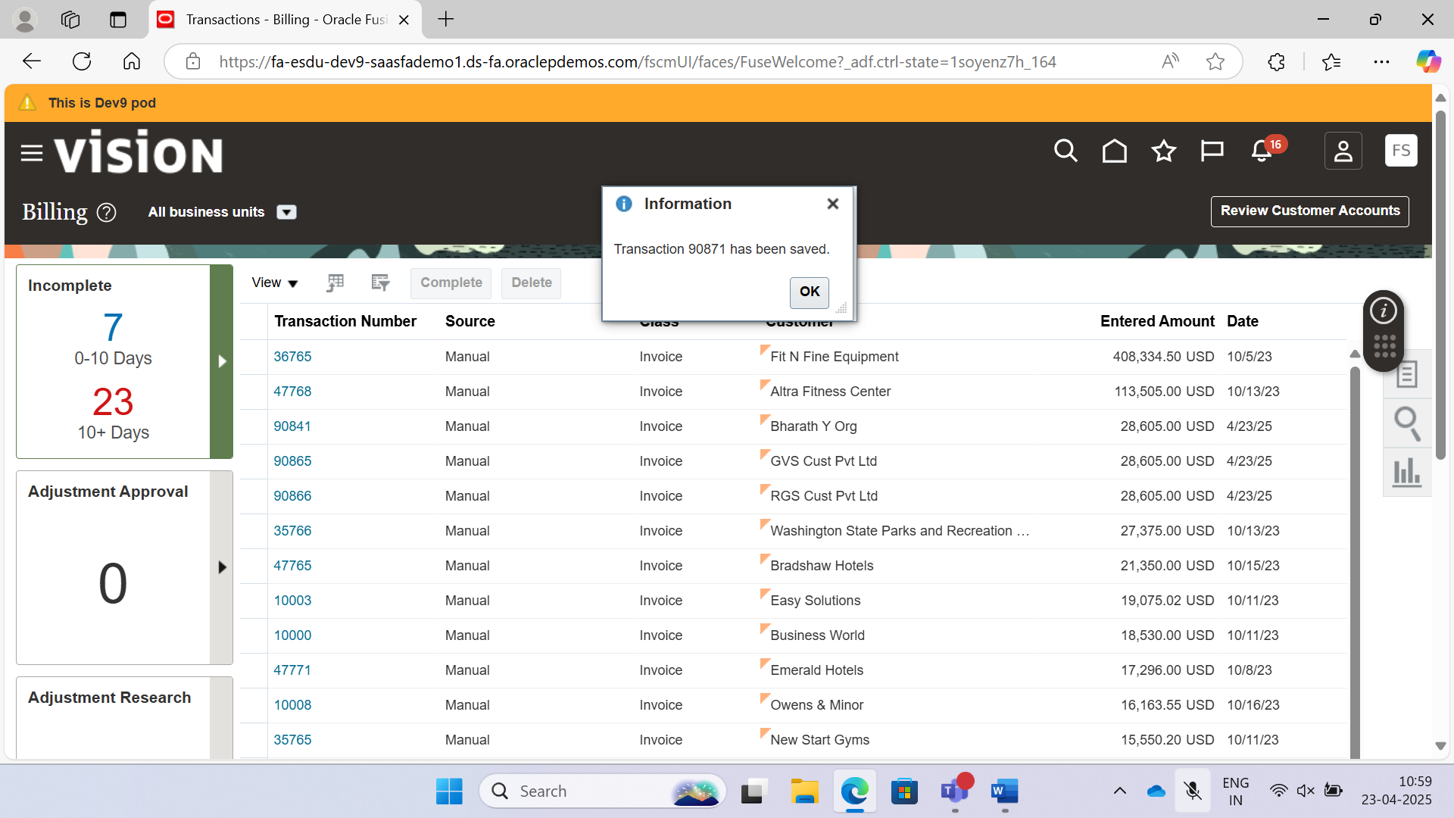 Click tasks, create transaction, Transaction Class: credit memo, business unit: US1 Business Unit, Transaction source: manual, Transaction Type: Credit Memo, Credit Reason: Discount, Bill to name: select the customer you created previously, under credit memo lines, give description: Additional Discount after billing, UOM: Ea, Reason: Discount, Quantity: 100, Unit Price: -5, Amount: 500, save, click complete and review.

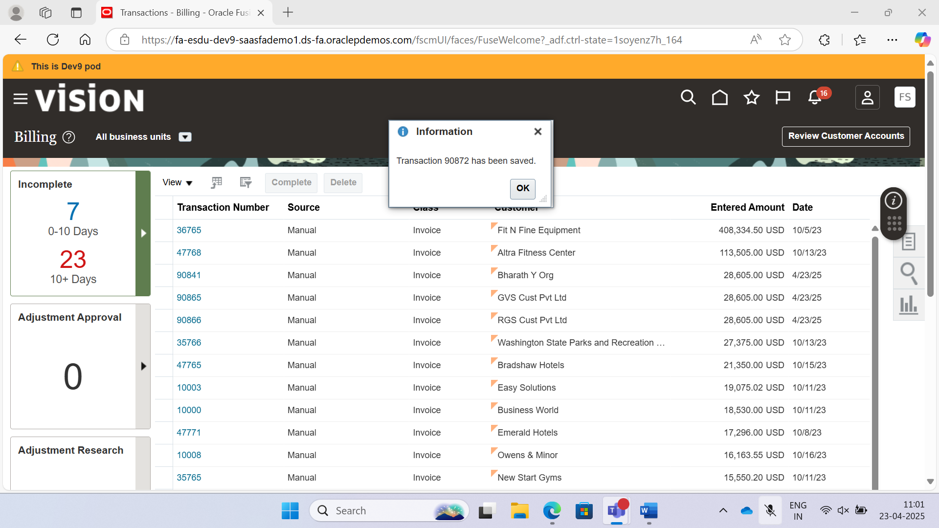

Home, Receivables, Billing, Tasks Panel, Manage Transactions, search previously created two transactions with site name, then select second one, under actions, select accounting draft, click view accounting, click ok.

Home, Receivables, Account Receivables , Tasks Panel, create receipt, Receipt type: Standard, Status: New, Business Unit: US1 Business Unit, Receipt method: EFT (Automatic), Receipt number: 1234567890, Currency: USD US Dollar, Name: Bank of America, Branch: New York, , Account number and name: Search For previously created customer, Click Create Bank Account, then select the bank account number that is created, click submit and apply manually.

Copy the receipt number, edit the receipt, click add application, Billing, Manage Transactions, search for the previously created transaction, copy the transaction number, paste the number in Application Reference, click add application, Billing, Manage Transactions, search for the another previously created transaction, copy the transaction number, paste the number in Application Reference, Applied amount for two application references -400, 10400 respectively, Make sure Available amount should become zero, Goto Actions, click account in draft, click actions, post to general ledger, click save and close. click save and close again.

Receivables, Account Receivables, Tasks, Review Customer account details, Search for the account,

Confirmed Cash means received from the customer,

FBDI:

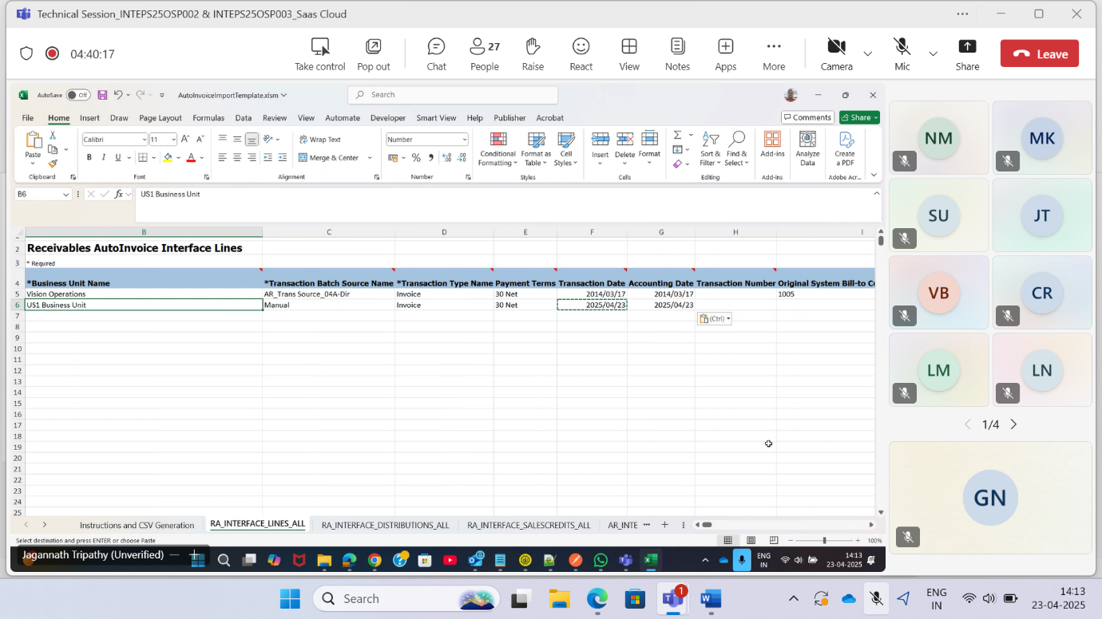

Download the AutoInvoiceImportTemplate.xlsm file,

Right Click on downloaded file and then click properties, check the unblock checkbox.

Then click apply and ok.

Then open the AutoInvoiceImportTemplate.xlsm file, then edit the file and give required values in corresponding fields.

Process 1

Now Generate Zip File.

Goto Schedule processes.

Schedule New Process.

Name: Load Interface File for Import.

Import Process: Import Autoinvoice

Upload the created zip file.

Process 2

Goto Schedule processes.

Schedule New Process.

Name: Import Autoinvoice

Transaction Source: Manual create own source, Under financials, Receivables, Manage Transaction Sources, select Receivables Import having standard transaction type as invoice, click on that and copy the Automatic Transaction Numbering, copy the Name: Receivables Import, paste the name in the Transaction batch source name existed in RA_INTERFACE_LINES_ALL sheet, Repeat the above Process 1 again. Then repeat the process 2 with below continuation

Goto Schedule processes.

Schedule New Process.

Name: Import Autoinvoice

Transaction Source: Receivables Import (search and select the Receivables Import )

Transaction Type: Invoice

From Customer: search the created customer

To Customer: search the created customer

Submit the process.

Billing, create transaction, under miscellaneous

Select values in the dropdown as Contract Invoice, update the field Invoice Transactions Flexfield Context in the RA_INTERFACE_LINES_ALL

Go to the Task “ ManageReceivables Descriptive Flexfields”

Goto Transaction Types.

Then find name of your context.

Search for the context and if you find the context then replace it with the contract flexfield.

Then repeat process 1 and process 2 from above steps.

7786748

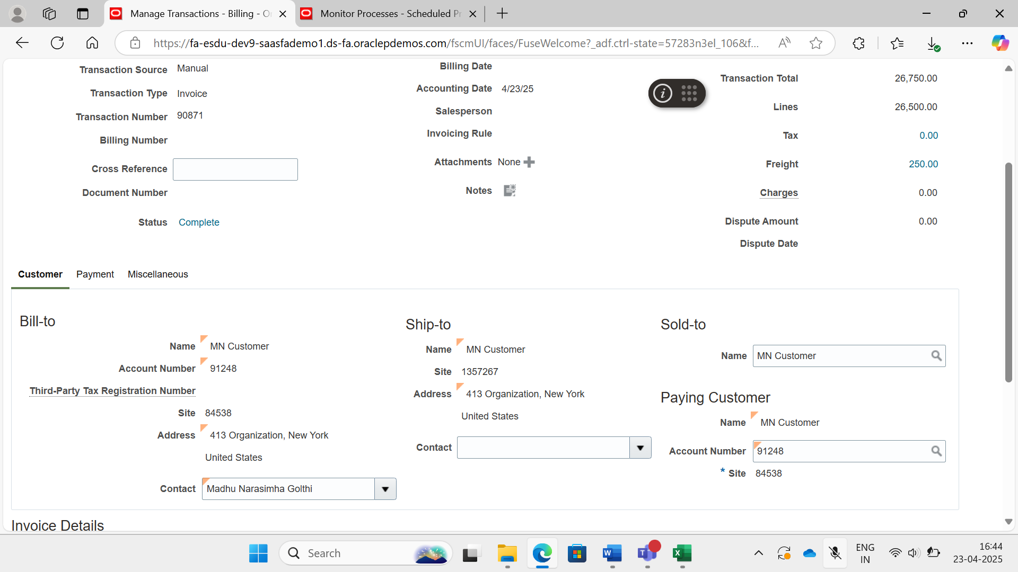

AL – Contract Invoice

HL – Our Context

**HCM Data Loader:**

My Client Groups, Data Exchange, under HCM Data Loader Section Click View Business Objects, Search for **Location** Business Object, Click on Location Business Object, File name should be Location.dat, File Discriminator should be Location.

Open Notepad, create a file with **Location.dat**, Copy the File Discriminator, Delimiter is “|”, give data as below by following the below navigation steps:

**Creating Location: [Location.dat]**

METADATA|Location|LocationCode|SetCode|LocationName|EffectiveStartDate|ActiveStatus|Country|AddressLine1|TownOrCity|Region2|PostalCode|EmployeeLocationFlag|ShipToSiteFlag|BillToSiteFlag|ReceivingSiteFlag|OfficeSiteFlag|StandardWorkingHours|StandardWorkingFrequency|SourceSystemId|SourceSystemOwner

MERGE|Location|MN_LOC_1|COMMON|MN_LOC_NM_1|1951/01/01|A|IN|457, HBR Layout|Bangalore|Karnataka|560027|Y|Y|Y|Y|Y|45|W|MN_LOC_1|HDL

MERGE|Location|MN_LOC_2|COMMON|MN_LOC_NM_2|1951/01/01|A|IN|136, Road No 1 Banjara Hills|Hyderabad|Telangana|500032|Y|Y|Y|Y|Y|45|W|MN_LOC_2|HDL

MERGE|Location|MN_LOC_3|COMMON|MN_LOC_NM_3|1951/01/01|A|IN|219, Tolichowki|Hyderabad|Telangana|500047|Y|Y|Y|Y|Y|45|W|MN_LOC_3|HDL

Then go to attributes tab in the instance, LocationId is automatically generated, you need to give the location code, Location code should be unique, then give setcode, set code can be common or you can give specific according to that, EED will be 31-Dec-4712, Effective start date is 01-Jan-1951, Date format should be **YYYY/MM/DD**, give ActiveStatus: use the value under lookup for the ActiveStatus row, go to reports and analytics in another window, browse catalog, click on new data model under new dropdown, create a query**, select * from lookup_value_vl where lookup_type=’ACTIVE_INACTIVE’** , Execute the Query then go to data tab, get the ACTIVE and INACTIVE value, e.g. 201, for active ‘A’, inactive ‘I’, place ‘A’ as Active Status in .dat file, then give Address Line1, for finding mandatory locations, go to locations option in home page, New Location, Enter Country before AddressLine1, and then Enter TownOrCity after AddressLine1, then modify the query with where clause **where country = ‘IN’**, you can search for corresponding Region2 in query, then enter postal code, enter EmployeeLocationFlag and search for all flag values in attributes flag, again go to query and search for the Lookup for StandardWorkingFrequency using query **, select * from lookup_value_vl where lookup_type = ‘FREQUENCY’,** give value of SourceSystemID as value of LocationId, **,**search for the SourceSystemOwner using **select * from lookup_value_vl where lookup_type = ‘HRC_SOURCE_SYSTEM_OWNER’,** give value as **HDL**,

Now create a zip file with the file, but not create a folder, directly convert the dat file to zip file.

Home, My Client Groups, Data Exchange, under HCM Data Loader Section Click Import and Load data, Click on Import file and then submit the zip file.

In View Business Objects, Search for the Org in Business Object name, go to component details tab.

**Create Organization and classifying as Departments [Organization.dat]**

METADATA|Organization|Name|EffectiveStartDate|ClassificationName|LocationCode|LocationSetCode|SourceSystemId|SourceSystemOwner

MERGE|Organization|MN Department 1|1951/01/01|Department|MN_LOC_1|COMMON|MN_DEPT_1|HDL

MERGE|Organization|MN Department 2|1951/01/01|Department|MN_LOC_2|COMMON|MN_DEPT_2|HDL

MERGE|Organization|MN Department 3|1951/01/01|Department|MN_LOC_3|COMMON|MN_DEPT_3|HDL

METADATA|OrgUnitClassification|ClassificationName|OrganizationName|EffectiveStartDate|SetCode|Status|SourceSystemId|SourceSystemOwner

MERGE|OrgUnitClassification|Department|MN Department 1|1951/01/01|COMMON|A|MN_DEPT_CL_1|HDL

MERGE|OrgUnitClassification|Department|MN Department 2|1951/01/01|COMMON|A|MN_DEPT_CL_2|HDL

MERGE|OrgUnitClassification|Department|MN Department 3|1951/01/01|COMMON|A|MN_DEPT_CL_3|HDL

Use query **Select * from hr_org_classifications**,

Use query **Select * from hr_org_classifications_tl where language=’US’**, to retrieve classification name,

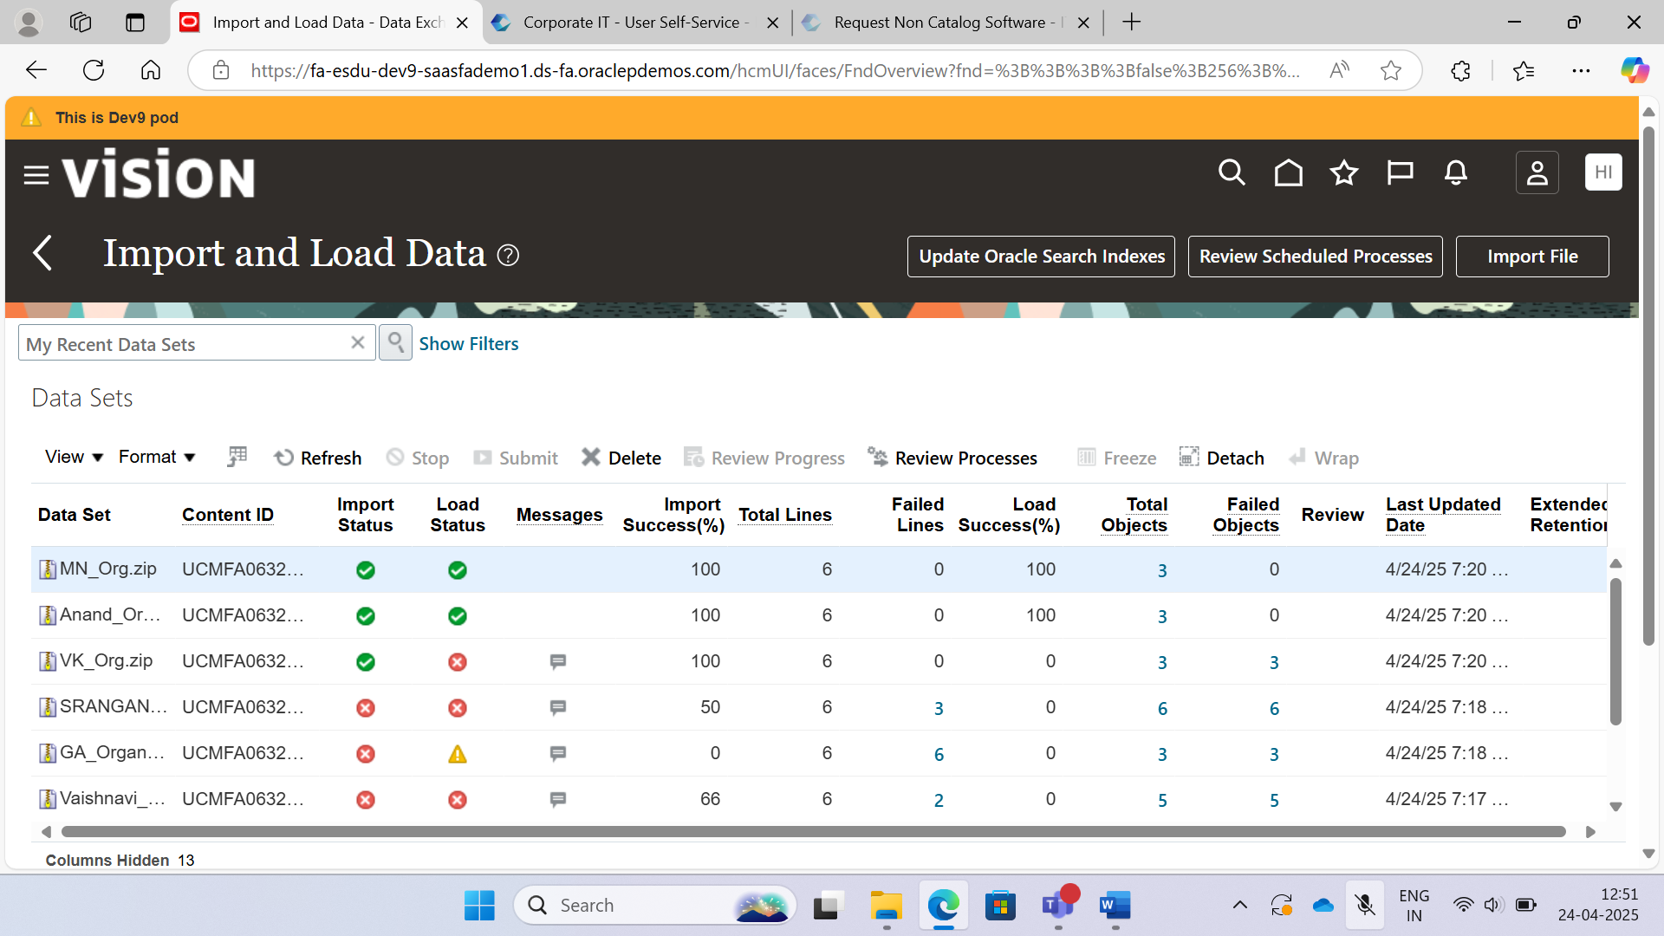

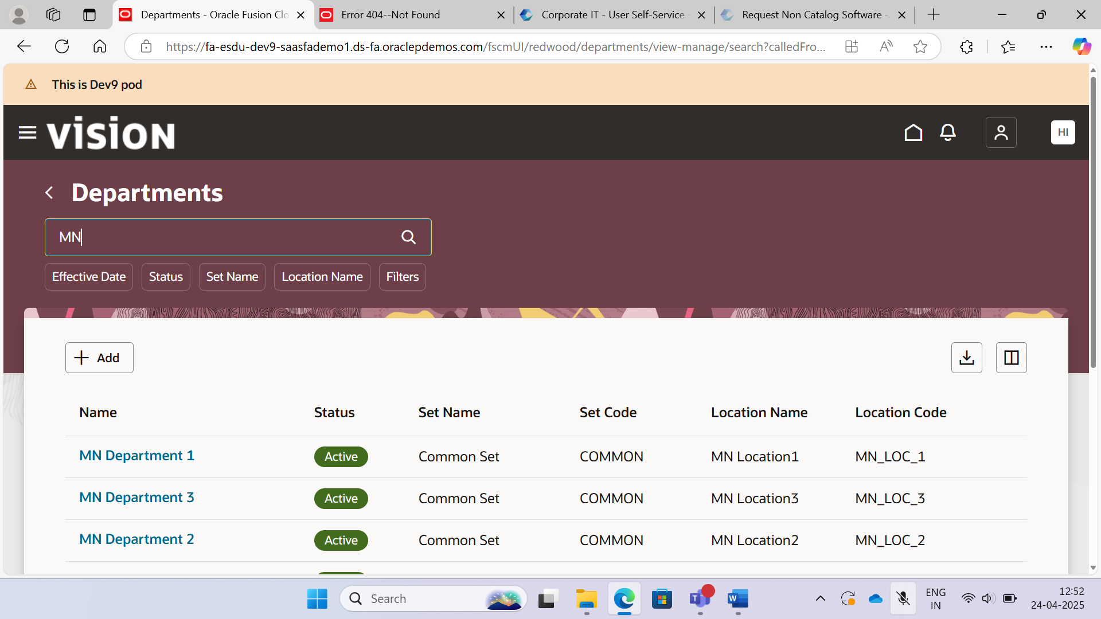

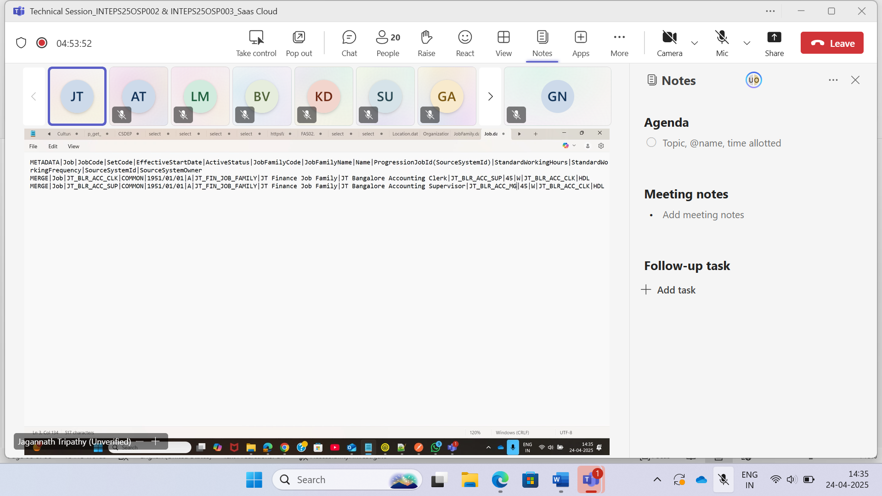

METADATA|JobFamily|JobFamilyCode|JobFamilyName|EffectiveStartDate|ActiveStatus|SourceSystemId|SourceSystemOwner

MERGE|JobFamily|MN_Fin_Job_Family|MN Finance Job Family|1951/01/01|A|MN_Fin_Job_Family|HDL

METADATA|Job|JobCode|SetCode|EffectiveStartDate|ActiveStatus|JobFamilyCode|JobFamilyName|Name|ProgressionJobId(SourceSystemId)|StandardWorkingHours|StandardWorkingFrequency|SourceSystemId|SourceSystemOwner

MERGE|Job|MN_BLR_ACC_CLK|COMMON|1951/01/01|A|MN_Fin_Job_Family|MN Finance Job Family|MN Bangalore Accounting Clerk|MN_BLR_ACC_SUP|45|W|MN_BLR_ACC_CLK|HDL

MERGE|Job|MN_BLR_ACC_SUP|COMMON|1951/01/01|A|MN_Fin_Job_Family|MN Finance Job Family|MN Bangalore Accounting Supervisor|MN_BLR_ACC_MGR|45|W|MN_BLR_ACC_SUP|HDL

MERGE|Job|MN_BLR_ACC_MGR|COMMON|1951/01/01|A|MN_Fin_Job_Family|MN Finance Job Family|MN Bangalore Accounting Manager||45|W|MN_BLR_ACC_MGR|HDL

**Order:**

Location, Organization, Job Family, Job, Position, Grades and Employee

**Legall Entity, Business Unit, Inventory, Department** using Organization Business Object.

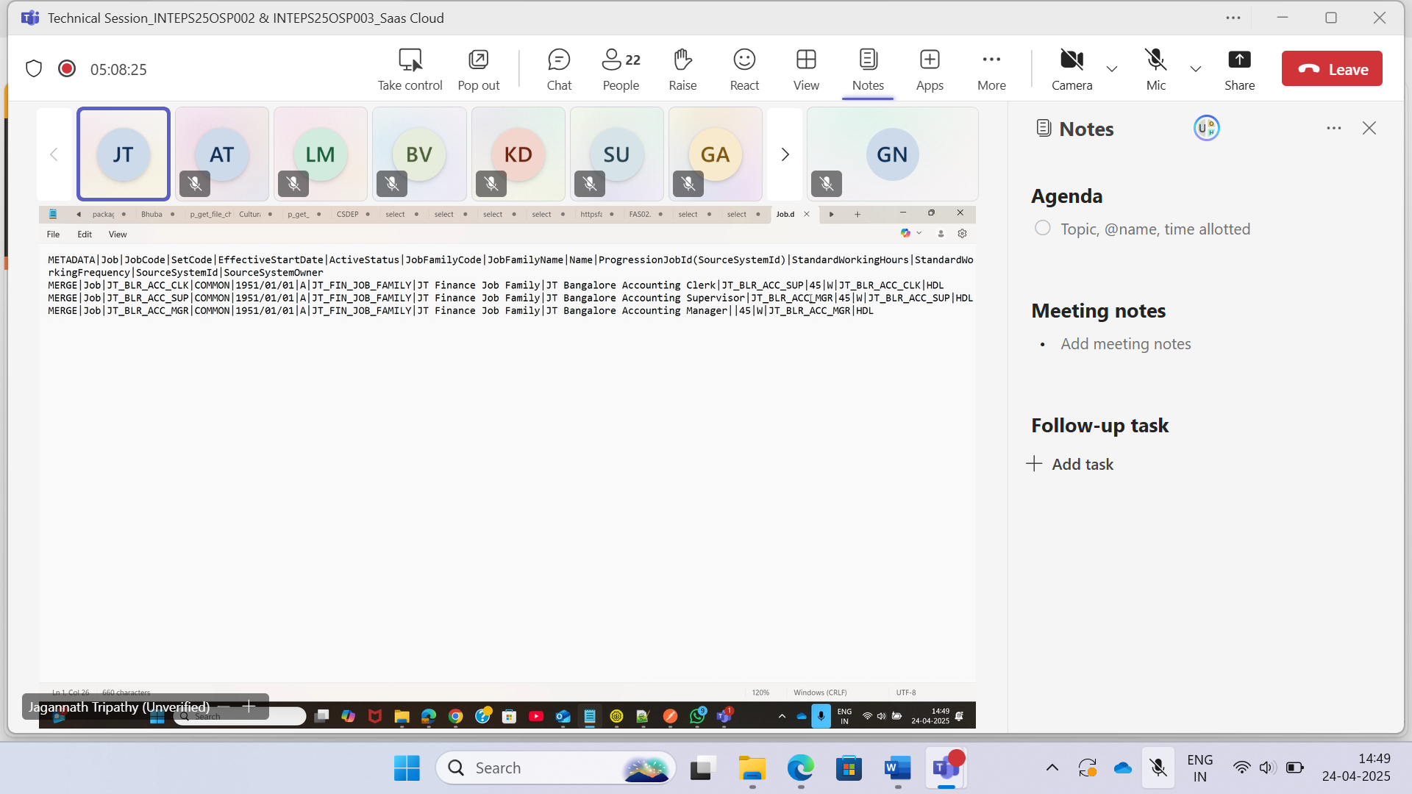

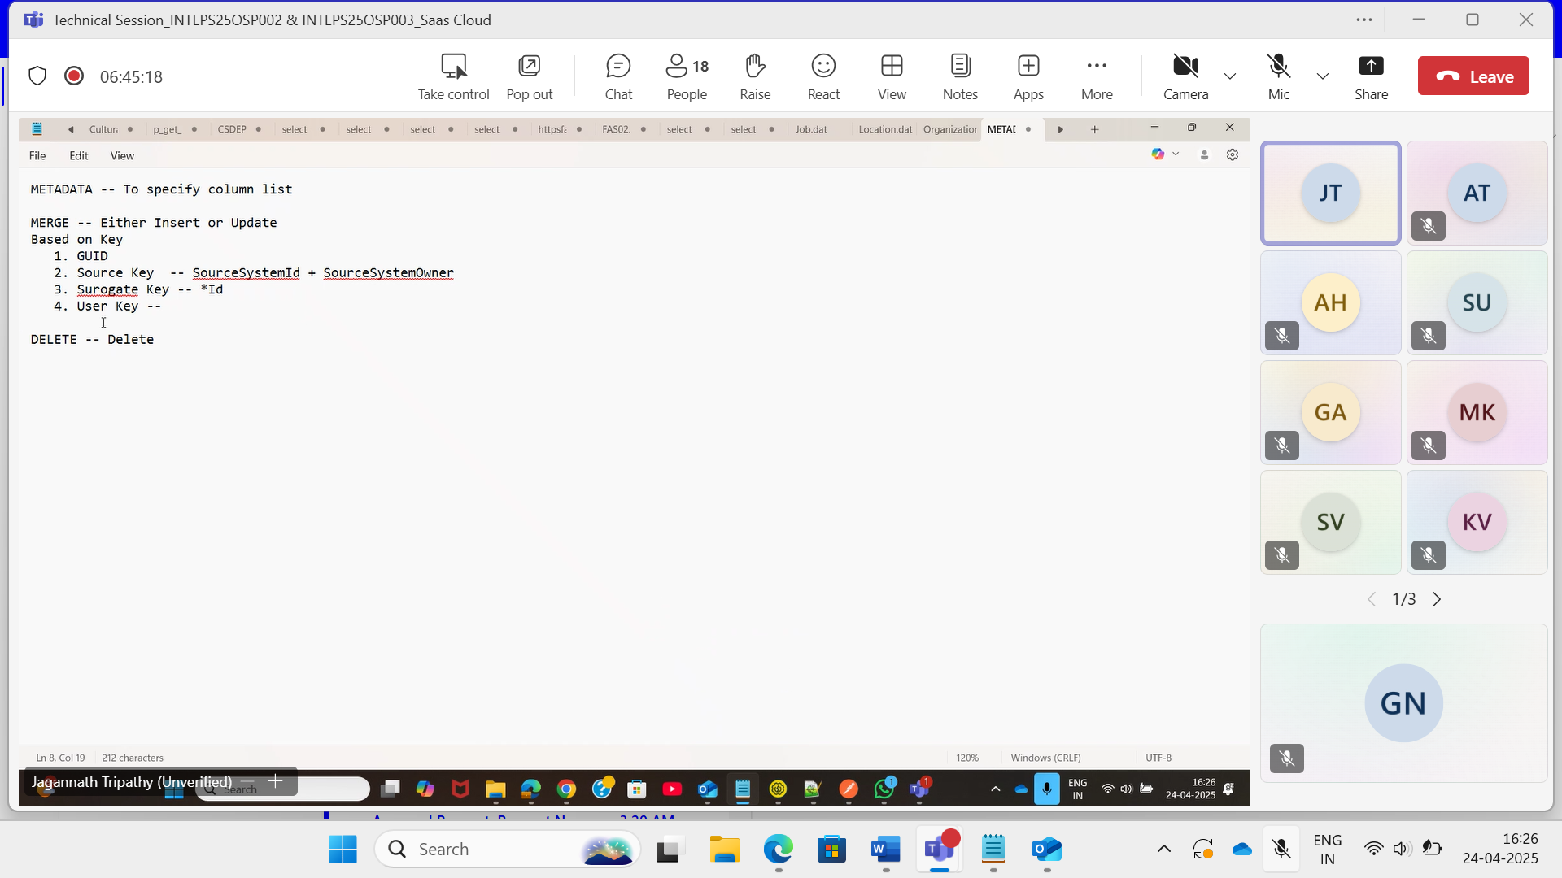

**Create Grade and Link it to the Position:**

In a zip file create a grade and link the to the position with a single file.

**Implementation:**

In Business Objects, Search and Click on Grade, go to attributes

**Creating Grade:**

METADATA|Grade|GradeCode|SetCode|EffectiveStartDate|ActiveStatus|GradeName|SourceSystemId|SourceSystemOwner

MERGE|Grade|MN_Grade|COMMON|1951/01/01|A|MN Grade X1|MN_GRD_X1|HDL

METADATA|GradeStep|GradeCode|SetCode|GradeStepName|EffectiveStartDate|CeilingStepFlag|GradeStepSequence|SourceSystemId|SourceSystemOwner

MERGE|GradeStep|MN_Grade|COMMON|A|1951/01/01|Y|3|MN_GRD_1_A|HDL

MERGE|GradeStep|MN_Grade|COMMON|B|1951/01/01|N|2|MN_GRD_1_B|HDL

MERGE|GradeStep|MN_Grade|COMMON|C|1951/01/01|N|1|MN_GRD_1_C|HDL

**Creating Position:**

METADATA|Position|BusinessUnitName|PositionCode|EffectiveStartDate|ActiveStatus|DepartmentName|EntryGradeCode|EntryGradeSetCode|EntryStepName|FTE|StandardWorkingFrequency|Frequency|FullPartTime|HeadCount|HiringStatus|JobCode|JobSetCode|LocationCode|LocationSetCode|Name|PositionType|RegularTemporary|StandardWorkingHours|WorkingHours|SourceSystemId|SourceSystemOwner

MERGE|Position|India Business Unit|MN_BLR_ACC_CLK|1951/01/01|A|MN Department 1|MN_Grade|COMMON|C|50|W|W|FULL_TIME|50|APPROVED|MN_BLR_ACC_CLK|COMMON|MN_LOC_1|COMMON|MN Bangalore Accounting Clerk|SHARED|R|45|45|MN_BLR_ACC_CLK|HDL

Department, Legal Entity, Business Unit and Inventory can be created using Organization Business Object.

Job Location, BU and Grade should already be created to create position.

Only After creating position, we can create employee.

The size of the Zip file should not exceed 10 MB.

**Creating Employee:**

Worker Business Object, view component Details Tab, Under Component Details find External Identifier section in left **Worker** Drop down

Effective Start date should the date employee joined.

PersonID, PersonNumber will be automatically generated.

Get the BloodType lookup tab to get the value of BloodType.

You can query in the data model of reports & analytics.

Select * from fnd_lookup_values_tl Where lookup_type = :P_LOOKUP_TYPE

Fnd_language

EffectiveStartDate and StartDate should be same in most of the normal situation, for a pending worker it may be different

Any entity can be linked with same zip file.

EnternalIDType from the lookup query: ORA_TCLOCK_BADGE_ID

Search for address with value as ADDRESS_TYPE as Value, use corresponding value having ADD at end **ORA_HRX_IN_CURR**.

Search for email type in EMAIL_TYPE

Select code that are valid in current legislation.

METADATA|Worker|EffectiveStartDate|ActionCode|BloodType|CorrespondenceLanguage|DateOfBirth|StartDate|SourceSystemId|SourceSystemOwner

MERGE|Worker|2025/04/21|HIRE|O+|US|2000/07/18|2025/04/21|MN_EMP_1|HDL

MERGE|Worker|2025/04/21|HIRE|B+|US|2000/08/18|2025/04/21|MN_EMP_2|HDL

METADATA|PersonAddress|AddressLine1|AddressType|PersonId(SourceSystemId)|EffectiveStartDate|Country|PostalCode|PrimaryFlag|Region2|TownOrCity|SourceSystemId|SourceSystemOwner

MERGE|PersonAddress|381, BTM Layout|ORA_HRX_IN_CURR|MN_EMP_1|2025/04/21|IN|560037|Y|Karnataka|Bangalore|MN_EMP_AD_1|HDL

MERGE|PersonAddress|379, BTM Layout|ORA_HRX_IN_CURR|MN_EMP_2|2025/04/21|IN|560037|Y|Karnataka|Bangalore|MN_EMP_AD_2|HDL

METADATA|PersonEmail|EmailAddress|EmailType|PersonId(SourceSystemId)|DateFrom|SourceSystemId|SourceSystemOwner

MERGE|PersonEmail|appala.narasimha@oraclepdemos.com|W1|MN_EMP_1|2025/04/21|MN_EMP_EM_1|HDL

MERGE|PersonEmail|rani.chemula@oraclepdemos.com|W1|MN_EMP_2|2025/04/21|MN_EMP_EM_2|HDL

METADATA|PersonImage|ImageName|ImageType|PrimaryFlag|PersonId(SourceSystemId)|Image|SourceSystemId|SourceSystemOwner

MERGE|PersonImage|Emp1|PROFILE|Y|MN_EMP_1|person-image-1.jpeg|MN_EMP_IM_1|HDL

MERGE|PersonImage|Emp2|PROFILE|Y|MN_EMP_2|person-image-2.jpeg|MN_EMP_IM_2|HDL

METADATA|PersonLegislativeData|LegislationCode|PersonId(SourceSystemId)|EffectiveStartDate|Sex|HighestEducationLevel|MaritalStatus|SourceSystemId|SourceSystemOwner

MERGE|PersonLegislativeData|IN|MN_EMP_1|2025/04/21|M|ZGSE_IN_Bach|S|MN_EMP_LD_1|HDL

MERGE|PersonLegislativeData|IN|MN_EMP_2|2025/04/21|F|ZGSE_IN_Bach|M|MN_EMP_LD_2|HDL

METADATA|PersonName|NameType|PersonId(SourceSystemId)|EffectiveStartDate|FirstName|LastName|LegislationCode|Title|SourceSystemId|SourceSystemOwner

MERGE|PersonName|GLOBAL|MN_EMP_1|2025/04/21|Appala|Narasimha|IN|MR.|MN_EMP_NM_1|HDL

MERGE|PersonName|GLOBAL|MN_EMP_2|2025/04/21|Rani|Chemula|IN|MRS.|MN_EMP_NM_2|HDL

METADATA|PersonNationalIdentifier|IssueDate|LegislationCode|NationalIdentifierType|NationalIdentifierNumber|PersonId(SourceSystemId)|PrimaryFlag|SourceSystemId|SourceSystemOwner

MERGE|PersonNationalIdentifier|2020/04/01|IN|ORA_HRX_IN_PAN|ABCDE9876F|MN_EMP_1|Y|MN_EMP_NI_1|HDL

MERGE|PersonNationalIdentifier|2020/04/01|IN|ORA_HRX_IN_PAN|ABCDE9865F|MN_EMP_2|Y|MN_EMP_NI_2|HDL

METADATA|PersonPhone|PhoneNumber|PhoneType|PersonId(SourceSystemId)|CountryCodeNumber|DateFrom|LegislationCode|PrimaryFlag|SourceSystemId|SourceSystemOwner

MERGE|PersonPhone|7386679655|WM|MN_EMP_1|91|2025/04/21|IN|Y|MN_EMP_PH_1|HDL

MERGE|PersonPhone|7386679656|WM|MN_EMP_2|91|2025/04/21|IN|Y|MN_EMP_PH_2|HDL

METADATA|WorkRelationship|LegalEmployerName|DateStart|WorkerType|PersonId(SourceSystemId)|ActionCode|PrimaryFlag|SourceSystemId|SourceSystemOwner

MERGE|WorkRelationship|India Legal Entity|2025/04/21|E|MN_EMP_1|HIRE|Y|MN_EMP_WR_1|HDL

MERGE|WorkRelationship|India Legal Entity|2025/04/21|E|MN_EMP_2|HIRE|Y|MN_EMP_WR_2|HDL

METADATA|WorkTerms|PeriodOfServiceId(SourceSystemId)|LegalEmployerName|DateStart|WorkerType|EffectiveLatestChange|EffectiveSequence|EffectiveStartDate|ActionCode|PrimaryWorkTermsFlag|SourceSystemId|SourceSystemOwner

MERGE|WorkTerms|MN_EMP_WR_1|India Legal Entity|2025/04/21|E|Y|1|2025/04/21|HIRE|Y|MN_EMP_WT_1|HDL

MERGE|WorkTerms|MN_EMP_WR_2|India Legal Entity|2025/04/21|E|Y|1|2025/04/21|HIRE|Y|MN_EMP_WT_2|HDL

METADATA|Assignment|WorkTermsAssignmentId(SourceSystemId)|EffectiveLatestChange|EffectiveSequence|EffectiveStartDate|ActionCode|AssignmentType|BusinessUnitShortCode|PositionCode|PositionOverrideFlag|PrimaryAssignmentFlag|SourceSystemId|SourceSystemOwner

MERGE|Assignment|MN_EMP_WT_1|Y|1|2025/04/21|HIRE|E|India Business Unit|MN_BLR_ACC_CLK|N|Y|MN_EMP_A_1|HDL

MERGE|Assignment|MN_EMP_WT_2|Y|1|2025/04/21|HIRE|E|India Business Unit|MN_BLR_ACC_CLK|N|Y|MN_EMP_A_2|HDL

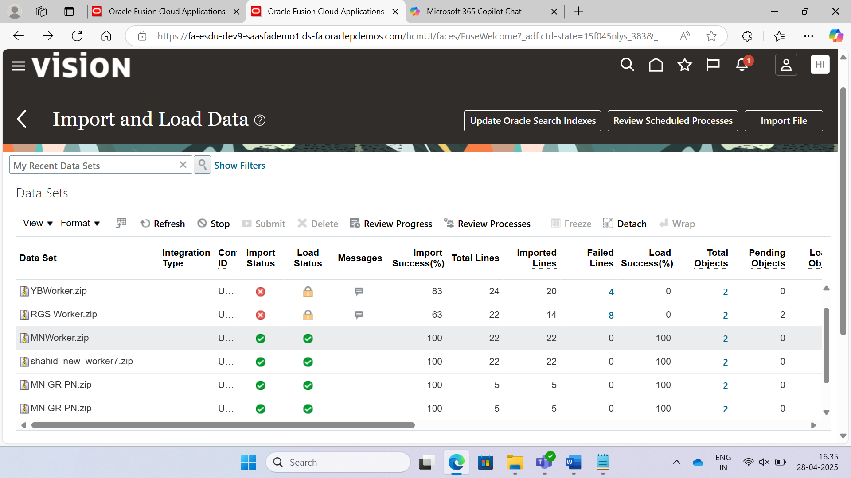

**HCM Extract** is an outbound interface to transfer data to outside of HCM.

**User entities** are nothing but pre-defined queries that are used to extract data.

Go to My Client Groups, Data Exchange, View User Entity Details, search for PER_EXT_SRC,

Database Items are columns available in user entity.

Context Required is the Mandatory parameters/attributes.

Context Set is the Optional Attributes.

Under Query tab we have pre-written query (read-only).

Go to My Client Groups, Data Exchange, Click Extract Definitions, Click + to create New, Click Full Profile (To Extract Entire data), Give Name, ESD: 1951/01/01, Consumer: Report (Create a BI Report that will use this data) or Undefined (XML), Click Ok, Go to Design Section, Give data group name: Employee DG, Tag name: Employee DG, user entity: PER_EXT_SEC_PERSON_UE click save, then select the Employee DG and click +, then give details in child data group, then go to attributes tab, add database item (columns available in user entity) [PID, PNUm, Pemail, Pephoe, ], click Save, click Validate, click Save, Goto Deliver section, give Delivery option name, type: None, click ok, click save. Go to Preview section, then give ESD, then click Preview, then Download.

Go to Design Tab, Click + to add data group, then search for the user entity by clicking on advance. Click + to create new DG select employee name existed UE. Go to connect data groups, select Extract Person ID under Parent DG Database Item, and Extract PER_EXT_HISTORY_PERSON_NAMES_UE Item, Click edit under Emp Name DG, select Extract Historical Person Name Type operator: =, Constant = ‘GLOBAL’ , click ok, click save. Select Emp Name DG, click + to create record, Name: Emp Name, go to attributes tab and click + to add database items [Person name type. Person Title, First Name, Last Name], click add, click validate, click back, click save, go to preview section.

Click Employee DG and create new DG: Emp Email DG, search for UE: PER_EXT_EMAIL_ADDRESSES_UE, then click in that EMP Email DG, then create record: Email record, click attributes tab in [email address, date from, date to, email type] click add, save it, go to Emp email DG and click Connect Data Groups, Go to Emp email DG and click Filters tab, edit criteria. Effective date, operator is between, click + add Date from and click + at operators to add “and” and then click + at first input field of criteria condition, date to in first field of criteria condition. Click ok and Save it. Select Employee DG, click + to add child data group, name: Emp Phone, select the PER_EXT_PHONES_UE, connect data groups automatically generated, Give below code in the filter tab

**Paste below in Email Filter**

(pay_report_utils.get_parameter_value_date('EFFECTIVE_DATE')

BETWEEN NVL( email_add.date_from, pay_report_utils.get_parameter_value_date('EFFECTIVE_DATE'))

AND NVL(email_add.date_to, pay_report_utils.get_parameter_value_date('EFFECTIVE_DATE'))

)

(pp.date_from=pp.date_to)

**Paste below in Phone Filter**

(pay_report_utils.get_parameter_value_date('EFFECTIVE_DATE')

BETWEEN NVL( pp.date_from, pay_report_utils.get_parameter_value_date('EFFECTIVE_DATE'))

AND NVL(pp.date_to, pay_report_utils.get_parameter_value_date('EFFECTIVE_DATE'))

)

Oracle has predefined templates for exporting data.

Effective Date is Mandatory Parameter.

Data Group links to user entity i.e. columns selected by user entity are linked to the data group.

Full Profile is selected to Extract Entire data.

Select Employee DG, then click create new DG, select UE as PER_EXT_WORK_RELATIONSHIP_UE, connect data groups using Extract Person Id and Person Relationship Person Id, with in that Work Relationship DG create another DG as Work Terms DG with UE as PER_EXT_SEC_ASSIGNMENT_UE, then connect using Person Relationship Period Of Service Id and Extract Assignment Period of service ID, in Work Terms DG add a filter, Extract Assignment Type in (‘ET’,’CT’,’NT’), With in Work Terms DG create Assignment DG with UE as PER_EXT_SEC_ASSIGNMENT_UE, add filter using Extract Assignment Type in (‘E’,’C’,’N’), then add record in that Assignment DG, In that record add attributes Assg name, number, Normal Hours, Type, Time Normal start, Time Normal finish, In Assignment DG, create a DG with Location DG name with UE and connect DGs with (DB Item)Extract Location Id and (Parent)Extract Assignment Location ID, create Record in that Location DG, with attributes as Extract Location Name, Region2, Postal Code, Country, TownOrCity, AddressLine1, Add a DG in Assignment DG with UE as PER_EXT_SEC_JOB_UE

**Decoded Database Item:**

It is used to represent the data in the data groups’ records in required format, like if the worker type = ‘E’, then we can show it as ‘Employee’ in the result.

**Filters**

**Filters** are used to narrow down the data set based on specific criteria. They are applied directly to the data groups to include or exclude records based on defined conditions. Filters are typically used for:

1. **Data Selection**:
   * Filters help in selecting specific records that meet certain criteria. For example, filtering employees based on their department or job role.
2. **Performance Optimization**:
   * By filtering out unnecessary data, filters can improve the performance of the extract process by reducing the volume of data being processed.
3. **Simplifying Extracts**:
   * Filters make it easier to manage and organize data by focusing only on relevant records.

**Rules**

**Rules** are used to enforce specific logic or conditions within the extract process. They can be more complex and dynamic compared to filters. Rules are typically used for:

1. **Data Validation**:
   * Rules can validate data entries to ensure they meet specific criteria before being included in the extract. For example, ensuring that an employee’s age is above a certain threshold.
2. **Conditional Logic**:
   * Rules can enforce business logic that must be met for data to be processed. For example, calculating an employee’s age and ensuring it meets certain conditions.
3. **Data Manipulation**:
   * Rules can perform complex calculations and transformations on data. For example, constructing a formatted phone number from various data elements.

**Practical Example**

Imagine you need to extract data for employees who are above a certain age and have a specific job role. Here’s how you might use filters and rules:

1. **Filters**:
   * Apply a filter to select employees with the job role “Manager”.
   * Apply another filter to select employees whose age is above 30.
2. **Rules**:
   * Use a rule to calculate the age of employees based on their date of birth.
   * Use another rule to validate that the calculated age meets the condition (e.g., age > 30).

**Parameters:**

Parameters are used to pass input values to the extract and then they will be used for filtering, and loading values in to the fast formulas.

**Summary element:**

It is used to group child elements to achieve aggregation. Sum, Max, Min, Average.

**Record Calculation:**

It is used to perform calculation on the records within a Data Group. E.g. Grouping phone extension, number which are existed in Employee Phone DG.

Select the Employee Record, under Attributes tab, click + to Add Decoded Database Item, Give name, Data Type: Text, Default Value: Unknown, Output Column: up to 7 are taken so prefer more than that, Database Item: search for Extract Person System Person Type, Decode Value: ‘EMP’, ‘Employee’, ‘CWK’, ‘Contractor’, ‘NWK’, ‘Non Worker’, click OK, Go to Define section, under parameters section, click add, Name: Person Type, data type: Text, Display: Yes, Display Format: Text, add another parameter, Name: Minimum Age, Data Type: Number, Display: Yes, Display Format: Text, Add another parameter by clicking add, Name: Minimum Age, data type: Number, Display: Yes, Display Format: Text, add another parameter, Name: Minimum Age, Data Type: Number, Display: Yes, Display Format: Text, Go to Design Section, click on the Employee Record under attributes tab click Add parameter, Give name, Data type: Number, Output Column: 15, Parameter: select previously created age parameter Minimum age, click Ok, Select Employee Record under attributes Tab click + to add string, Name: Comment, Data Type: Text, String Value: Extract Employees by Narasimha, Click Ok, Select Employee Record under attributes tab click summary element, Data Type: Text, Output Column: 25, Aggregate Function: maximum, Aggregate Record Name: Emp Email DG Emp Email Record, Aggregate Attribute: Extract E-mail Address, Click Ok, click Save, click Validate.

**Note:** Whenever we create a Record in a Data Group, a Fast Formula is automatically created by the oracle, these records’ attributes are available in that fast formula.

Under DG Properties, select the Employee Record, Under Generated Fast Formula we can Find Fast Formula Id, use that and search in Fast Formulas using search bar, use that Fast Formula to know about variable names.

Under Fast Formulas, Click + to add Fast Formula, Formula Name: MN Concat Phone Number, Type: Extract Rule, ESD: 1/1/1951, Click Continue, place below “MN Concatenate Phone Number” formula in the Formula Text, Click Compile, Refresh.

**Fast Formula:**

/********************************************

Fast Formula Name: MN Concatenate Phone Number

Created By: Madhu Narasimha

********************************************/

DEFAULT FOR DATA_ELEMENTS IS EMPTY_TEXT_TEXT

INPUTS ARE DATA_ELEMENTS(TEXT_TEXT)

l_phone_number = ' '

IF DATA_ELEMENTS.EXISTS('EPCCN6') THEN (

l_phone_number = '+' || DATA_ELEMENTS['EPCCN6'] || '-'

)

IF DATA_ELEMENTS.EXISTS('Extract_Phone_Area_Code') THEN (

l_phone_number = l_phone_number || DATA_ELEMENTS['Extract_Phone_Area_Code'] || '-'

)

IF DATA_ELEMENTS.EXISTS('Extract_Phone_Number') THEN (

l_phone_number = l_phone_number || DATA_ELEMENTS['Extract_Phone_Number']

)

IF DATA_ELEMENTS.EXISTS('Extract_Phone_Extension') THEN (

l_phone_number = l_phone_number || '-' || DATA_ELEMENTS['Extract_Phone_Extension']

)

RULE_VALUE = l_phone_number

RETURN RULE_VALUE

Navigate to My Client Groups, Data Exchange, Extract Definitions, select your definition, Go to Design Section, then click Employee Phone Record, Under Attributes Tab click Add Rule, Give Name, Data Type: Text(Depends on data type of variable used in the return statement of corresponding fast formula), Output Column: 10, Rule: select MN Concatenate Phone Number, click ok.

Under DG Properties, select the Employee Record, Under Generated Fast Formula we can Find Fast Formula Id, use that and search in Fast Formulas using search bar, use that Fast Formula to know about variable names.

Under Fast Formulas, Click + to add Fast Formula, Formula Name: MN Calculate Age Number, Type: Extract Rule, ESD: 1/1/1951, Click Continue, place below “MN Calculate Age” formula in the Formula Text, Click Compile, Refresh.

**Fast Formula:**

/********************************************

Fast Formula Name: MN Calculate Age

Created By: Madhu Narasimha

********************************************/

/********************************************

Fast Formula Name: MN Calculate Age

Created By: Madhu Narasimha

********************************************/

DEFAULT FOR DATA_ELEMENTS IS EMPTY_TEXT_TEXT

DEFAULT FOR PARAMS IS EMPTY_TEXT_TEXT

INPUTS ARE DATA_ELEMENTS(TEXT_TEXT), PARAMS(TEXT_TEXT)

l_dob = to_date('01-01-1951', 'dd-mm-yyyy')

l_effdt = to_date('01-01-1951', 'dd-mm-yyyy')

l_age = ' '

IF PARAMS.EXISTS('EFFECTIVE_DATE') THEN (

l_effdt = to_date(PARAMS['EFFECTIVE_DATE'])

)

IF DATA_ELEMENTS.EXISTS('Person_Date_of_Birth') THEN (

l_dob = to_date(DATA_ELEMENTS['Person_Date_of_Birth'])

)

l_months = floor(months_between(l_effdt, l_dob))

l_days = days_between(l_effdt, add_months(l_dob, l_months))

l_years = floor(l_months/12)

l_months = l_months - l_years*12

IF l_years > 0 THEN (

l_age = to_char(l_years) || ' years '

)

IF l_months > 0 THEN (

l_age = l_age || ' ' || to_char(l_months) || ' months '

)

IF l_days > 0 THEN (

l_age = l_age || ' ' || to_char(l_days) || ' days '

)

RULE_VALUE = l_age

RETURN RULE_VALUE

Navigate to My Client Groups, Data Exchange, Extract Definitions, select your definition, Go to Design Section, then click Employee Record, Under Attributes Tab click Add Rule, Give Name, Data Type: Text(Depends on data type of variable used in the return statement of corresponding fast formula), Output Column: 10, Rule: select MN Calculate Age, click ok.

Then in the Employee DG, we should have a filter that should use the parameters.

Click the Employee DG, then under Filters tab click add, and then click edit, write the filter as “Extract Person System Person Type = Person Type Param And Extract Person ID = Minimum Age Effective Date”, then go to advanced, copy the code snippet, paste it in the notepad/any editor, then remove the last placed things up to And (Including And should be removed), then go to Advanced, again copy the code snippet and paste it in the notepad/any editor, then generate below code based on that, then click validate, then click ok, click save, click validate.

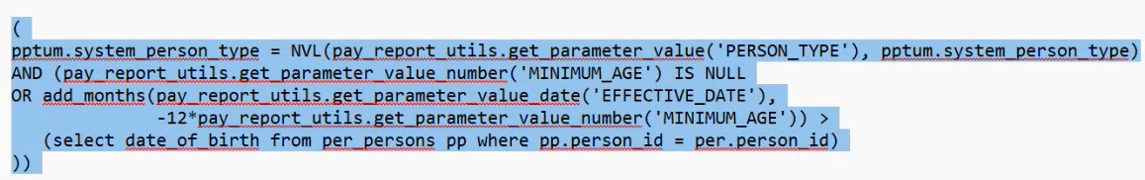

pptum.system_person_type = NVL(pay_report_utils.get_parameter_value('PERSON_TYPE'), pptum.system_person_type)

AND (pay_report_utils.get_parameter_value_number('MINIMUM_AGE') IS NULL

OR add_months(pay_report_utils.get_parameter_value_date('EFFECTIVE_DATE'),

-12 * pay_report_utils.get_parameter_value_number('MINIMUM_AGE')) >

(select date_of_birth from per_persons pp where pp.person_id = per.person_id)

)

Then Navigate My Client Groups, Data Exchange, under HCM Extracts, click Submit Extracts search for your Extract, click on the extract, Give unique name for the Extract instance name, Give Effective date as today date, Minimum age: 35, Person Type: EMP,

Then click Submit.

My Client Groups, Data Exchange, Click View Extract Results, Search for your Instance, If there are any alerts in the Instance Details Drop Down, copy the alters occurring process ID, check the process in Schedule Process Tab.

After Successful Execution in Instance Details, In Extract Delivery Options download the output files of the extract.

Parent: Extract Assignment Period of service ID

DB I: Person Relationship Period Of Service Id

Search for your Extract Definition in the Extract Definitions, Click on that and click validate, then click on Export as XML.

maxOccurs: Unbounded – occurs multiple times, we should use for loop.

Then Open Word, Write the RTF Content like below:

Reports and Analytics, Browse Catalog, Under Create drop down, Create a Report in the data model: Shared, Human Capital Management, Payroll, Data Model, reportsAndAnalytics Data Model(you need to select the data model), Then click on the upload template, then give details and RTF File, Then click view list, then select PDF as Default Output, Then save (Save your report in the Shared Folder, Custom, Your Folder), Click Catalog, then Navigate to the report in the Shared Folder/Custom/Your Folder, click more on the report, then click History, then copy the Path of the report (/Custom/Saas/Employee Extract Report.xdo),

Now My Client Groups, Data Exchange, under HCM Extracts, Extract Definitions, search for your Extract Definition, click on three dots, click copy or rename, Enter the new name, select copy radio button, Consumer: Report, then click ok, Then open the new extract Definition. Go to Deliver Section, Delete the Deliver, create a new one, Name: MN Deliver Report, Deliver Type: None, click ok, Paste the Path of the Report (/Custom/Saas/Employee Extract Report.xdo) in the Report Field, Output Type: PDF, Template Name: Give the name of Layout that you created previously to upload the RTF – It can be obtained by clicking edit option under the Report name, Click Ok, Click Save, Click Validate,

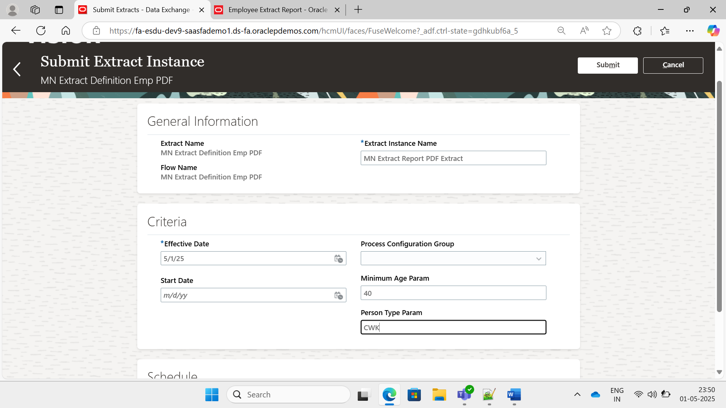

Create a Word File to write the template using header and padding.

Report Path: /Custom/Saas/Employee Extract EText Report.xdo

Template Name: Extract EText Template

Report Path: /Custom/Saas/copy of Employee Extract Report.xdo

|  |  |  |  |  |  |
| --- | --- | --- | --- | --- | --- |
|  | Instance Details |  | |  |  | | --- | --- | | [Download File](https://fa-esdu-dev9-saasfademo1.ds-fa.oraclepdemos.com/hcmUI/faces/FndOverview?fnd=%3B%3B%3B%3Bfalse%3B256%3B%3B%3B&fndGlobalItemNodeId=itemNode_workforce_management_data_exchange&_afrLoop=31998376562245118&_afrWindowMode=0&_afrWindowId=16bnktbzv7&_adf.ctrl-state=euo3uz44a_353&_afrFS=16&_afrMT=screen&_afrMFW=1413&_afrMFH=660&_afrMFDW=1280&_afrMFDH=720&_afrMFC=8&_afrMFCI=0&_afrMFM=0&_afrMFR=129&_afrMFG=0&_afrMFS=0&_afrMFO=0) | [Collapse](https://fa-esdu-dev9-saasfademo1.ds-fa.oraclepdemos.com/hcmUI/faces/FndOverview?fnd=%3B%3B%3B%3Bfalse%3B256%3B%3B%3B&fndGlobalItemNodeId=itemNode_workforce_management_data_exchange&_afrLoop=31998376562245118&_afrWindowMode=0&_afrWindowId=16bnktbzv7&_adf.ctrl-state=euo3uz44a_353&_afrFS=16&_afrMT=screen&_afrMFW=1413&_afrMFH=660&_afrMFDW=1280&_afrMFDH=720&_afrMFC=8&_afrMFCI=0&_afrMFM=0&_afrMFR=129&_afrMFG=0&_afrMFS=0&_afrMFO=0)Collapse | |

|  |  |  |  |  |  |  |  |  |  |  |  |  |  |  |  |  |  |  |  |  |  |  |  |  |  |  |  |  |  |  |  |  |  |  |  |  |
| --- | --- | --- | --- | --- | --- | --- | --- | --- | --- | --- | --- | --- | --- | --- | --- | --- | --- | --- | --- | --- | --- | --- | --- | --- | --- | --- | --- | --- | --- | --- | --- | --- | --- | --- | --- | --- |
| |  |  |  |  |  |  |  |  | | --- | --- | --- | --- | --- | --- | --- | --- | | |  |  |  | | --- | --- | --- | | Succeeded | Extract Run | [Download File](https://fa-esdu-dev9-saasfademo1.ds-fa.oraclepdemos.com/hcmUI/faces/FndOverview?fnd=%3B%3B%3B%3Bfalse%3B256%3B%3B%3B&fndGlobalItemNodeId=itemNode_workforce_management_data_exchange&_afrLoop=31998376562245118&_afrWindowMode=0&_afrWindowId=16bnktbzv7&_adf.ctrl-state=euo3uz44a_353&_afrFS=16&_afrMT=screen&_afrMFW=1413&_afrMFH=660&_afrMFDW=1280&_afrMFDH=720&_afrMFC=8&_afrMFCI=0&_afrMFM=0&_afrMFR=129&_afrMFG=0&_afrMFS=0&_afrMFO=0) | |  |  |   Process ID  7819735  Status  Succeeded | |  | | --- | |  | | | [Expand](https://fa-esdu-dev9-saasfademo1.ds-fa.oraclepdemos.com/hcmUI/faces/FndOverview?fnd=%3B%3B%3B%3Bfalse%3B256%3B%3B%3B&fndGlobalItemNodeId=itemNode_workforce_management_data_exchange&_afrLoop=31998376562245118&_afrWindowMode=0&_afrWindowId=16bnktbzv7&_adf.ctrl-state=euo3uz44a_353&_afrFS=16&_afrMT=screen&_afrMFW=1413&_afrMFH=660&_afrMFDW=1280&_afrMFDH=720&_afrMFC=8&_afrMFCI=0&_afrMFM=0&_afrMFR=129&_afrMFG=0&_afrMFS=0&_afrMFO=0) | | |  |  |  | | --- | --- | --- | | Succeeded | ElevatedFlowEssJobDefn | [Download File](https://fa-esdu-dev9-saasfademo1.ds-fa.oraclepdemos.com/hcmUI/faces/FndOverview?fnd=%3B%3B%3B%3Bfalse%3B256%3B%3B%3B&fndGlobalItemNodeId=itemNode_workforce_management_data_exchange&_afrLoop=31998376562245118&_afrWindowMode=0&_afrWindowId=16bnktbzv7&_adf.ctrl-state=euo3uz44a_353&_afrFS=16&_afrMT=screen&_afrMFW=1413&_afrMFH=660&_afrMFDW=1280&_afrMFDH=720&_afrMFC=8&_afrMFCI=0&_afrMFM=0&_afrMFR=129&_afrMFG=0&_afrMFS=0&_afrMFO=0) | |  |  |   Process ID  7819736  Status  Succeeded | |  | | --- | |  | | | [Expand](https://fa-esdu-dev9-saasfademo1.ds-fa.oraclepdemos.com/hcmUI/faces/FndOverview?fnd=%3B%3B%3B%3Bfalse%3B256%3B%3B%3B&fndGlobalItemNodeId=itemNode_workforce_management_data_exchange&_afrLoop=31998376562245118&_afrWindowMode=0&_afrWindowId=16bnktbzv7&_adf.ctrl-state=euo3uz44a_353&_afrFS=16&_afrMT=screen&_afrMFW=1413&_afrMFH=660&_afrMFDW=1280&_afrMFDH=720&_afrMFC=8&_afrMFCI=0&_afrMFM=0&_afrMFR=129&_afrMFG=0&_afrMFS=0&_afrMFO=0) |  |  |  |  |  |  |  |  |  | | --- | --- | --- | --- | --- | --- | --- | --- | | |  |  |  | | --- | --- | --- | | Warning | Archive and Generate XML | [Download File](https://fa-esdu-dev9-saasfademo1.ds-fa.oraclepdemos.com/hcmUI/faces/FndOverview?fnd=%3B%3B%3B%3Bfalse%3B256%3B%3B%3B&fndGlobalItemNodeId=itemNode_workforce_management_data_exchange&_afrLoop=31998376562245118&_afrWindowMode=0&_afrWindowId=16bnktbzv7&_adf.ctrl-state=euo3uz44a_353&_afrFS=16&_afrMT=screen&_afrMFW=1413&_afrMFH=660&_afrMFDW=1280&_afrMFDH=720&_afrMFC=8&_afrMFCI=0&_afrMFM=0&_afrMFR=129&_afrMFG=0&_afrMFS=0&_afrMFO=0) | |  |  |   Process ID  7819737  Status  Succeeded | |  | | --- | |  | | | [Expand](https://fa-esdu-dev9-saasfademo1.ds-fa.oraclepdemos.com/hcmUI/faces/FndOverview?fnd=%3B%3B%3B%3Bfalse%3B256%3B%3B%3B&fndGlobalItemNodeId=itemNode_workforce_management_data_exchange&_afrLoop=31998376562245118&_afrWindowMode=0&_afrWindowId=16bnktbzv7&_adf.ctrl-state=euo3uz44a_353&_afrFS=16&_afrMT=screen&_afrMFW=1413&_afrMFH=660&_afrMFDW=1280&_afrMFDH=720&_afrMFC=8&_afrMFCI=0&_afrMFM=0&_afrMFR=129&_afrMFG=0&_afrMFS=0&_afrMFO=0) | | |  |  |  | | --- | --- | --- | | Error | MN EText Deliver | [Download File](https://fa-esdu-dev9-saasfademo1.ds-fa.oraclepdemos.com/hcmUI/faces/FndOverview?fnd=%3B%3B%3B%3Bfalse%3B256%3B%3B%3B&fndGlobalItemNodeId=itemNode_workforce_management_data_exchange&_afrLoop=31998376562245118&_afrWindowMode=0&_afrWindowId=16bnktbzv7&_adf.ctrl-state=euo3uz44a_353&_afrFS=16&_afrMT=screen&_afrMFW=1413&_afrMFH=660&_afrMFDW=1280&_afrMFDH=720&_afrMFC=8&_afrMFCI=0&_afrMFM=0&_afrMFR=129&_afrMFG=0&_afrMFS=0&_afrMFO=0) | |  |  |   Process ID  7820105  Status  Error | |  | | --- | |  | | | [Expand](https://fa-esdu-dev9-saasfademo1.ds-fa.oraclepdemos.com/hcmUI/faces/FndOverview?fnd=%3B%3B%3B%3Bfalse%3B256%3B%3B%3B&fndGlobalItemNodeId=itemNode_workforce_management_data_exchange&_afrLoop=31998376562245118&_afrWindowMode=0&_afrWindowId=16bnktbzv7&_adf.ctrl-state=euo3uz44a_353&_afrFS=16&_afrMT=screen&_afrMFW=1413&_afrMFH=660&_afrMFDW=1280&_afrMFDH=720&_afrMFC=8&_afrMFCI=0&_afrMFM=0&_afrMFR=129&_afrMFG=0&_afrMFS=0&_afrMFO=0) | |

**Source Key**

**Definition:**

A **source key** is a combination of two attributes:

1. **SourceSystemOwner**: Identifies where the data originated (e.g., the name of the source system).
2. **SourceSystemId**: The ID used in the source system to uniquely identify the record.

**Purpose:**

Source keys are used for both creating and updating records. They are particularly useful for ongoing integrations where data is maintained in the source system.

**Example:**

Imagine you have an employee record in an external HR system called "HRMS". You want to load this employee into Oracle Fusion using HDL.

In this example:

METADATA|Worker|EffectiveStartDate|ActionCode|SourceSystemId|SourceSystemOwner

MERGE|Worker|2025/04/21|HIRE|EMP12345|HRMS

* **SourceSystemOwner** is "HRMS".
* **SourceSystemId** is "EMP12345".

When you later update this employee record, you use the same source key to identify the record.

**User Key**

**Definition:**

A **user key** consists of one or more attributes that uniquely identify a record. These attributes are visible on the user interface and are user-friendly.

**Purpose:**

User keys are used for both creating and updating records. They are useful when the source key is unknown or when referencing objects not created with a source key.

**Example:**

METADATA|Job|JobCode|SetCode|JobName|SourceSystemId|SourceSystemOwner

MERGE|Job|MN_JOB_1|COMMON|Accountant|MN_JOB_1|HDL

Imagine you are creating a job record in Oracle Fusion. The job is identified by its job code and set code.

In this example:

* **JobCode** is "MN_JOB_1".
* **SetCode** is "COMMON".

These attributes together form the user key for the job record.

**GUID (Globally Unique Identifier)**

* + **Generation**: GUIDs are generated by Oracle Fusion when a record is created. They are stored in the Integration Key Map table.
  + **Usage**: GUIDs are used for updating or deleting existing records. Since GUIDs are generated by the system, they can't be used when creating new records.
  + **Example**: Updating an employee record using GUID.

METADATA|Worker|EffectiveStartDate|ActionCode|GUID|SourceSystemId|SourceSystemOwner

MERGE|Worker|2025/04/21|UPDATE|88ABCD164738983|MN_EMP_1|HDL

**Surrogate Key**

* + **Generation**: Surrogate keys are numeric values generated by Oracle Fusion when a record is created. They are stored on the object itself.
  + **Usage**: Surrogate keys are used for updating or deleting existing records. They can't be used when creating new records.
  + **Example**: Updating a job record using surrogate key.

METADATA|Job|JobCode|SetCode|SurrogateId|SourceSystemId|SourceSystemOwner

MERGE|Job|MN_JOB_1|COMMON|8899933355517|MN_JOB_1|HDL

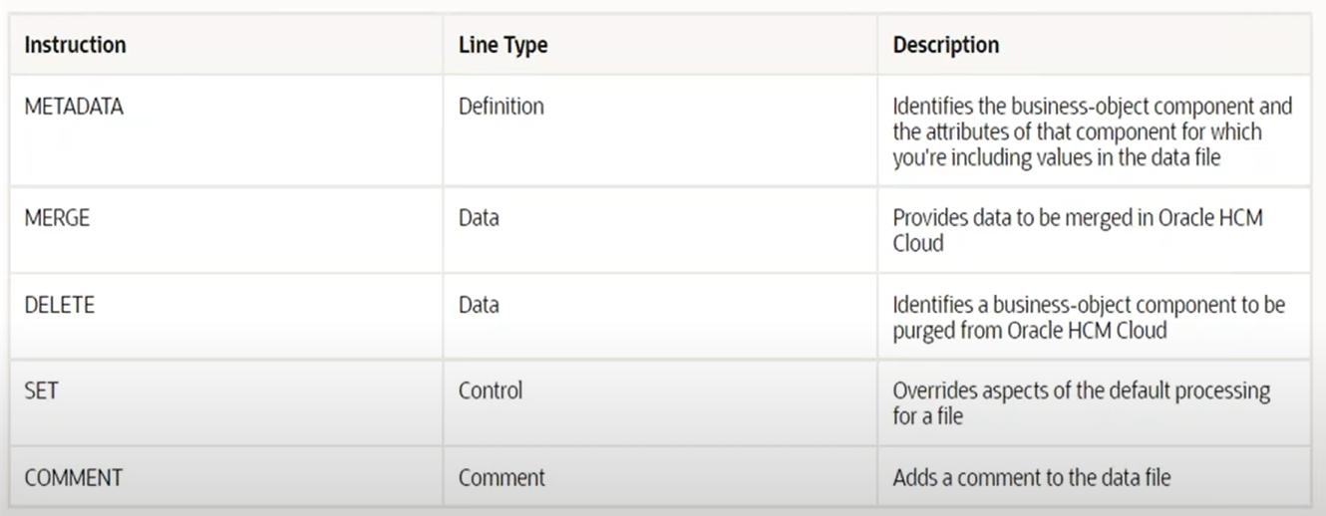

**Business Object** are instances that having bulk-loading capabilities with the help of components and attributes.